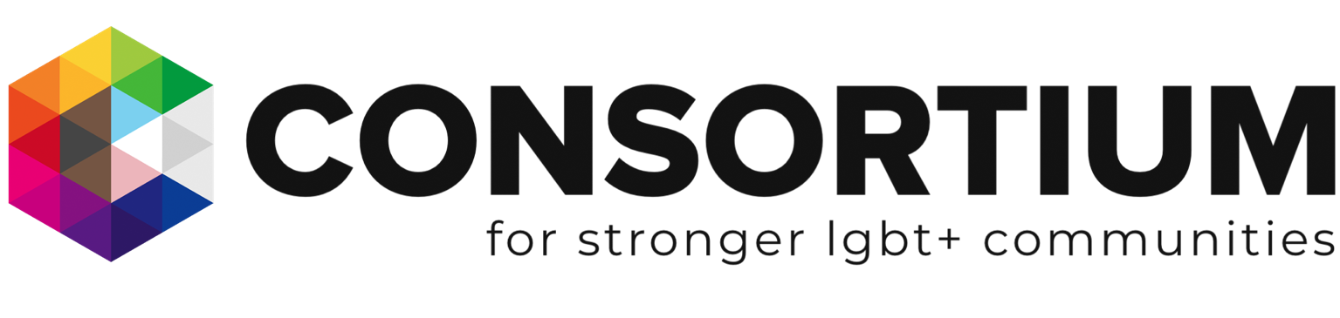

We undertake this skills audit for all our trustees. No trustee is intended to have all these skills/areas of experience. We use this as a guide to identify gaps in our collective skills and experience.
Name:
Skill/Area of Experience | None | Basic Skills/ knowledge | Skilled/ Knowledgeable | Proficient/ Expert
Advocacy or Guidance Experience
Broadcasting/Media Experience
–Marketing and PR
Campaigning
–IT infrastructure
IT and digital skills
Change Management
Charity Governance
Conflict Resolution and mediation
Business Development
Finance
–Corporate relationship management and fundraising
HR
Income Generation
Commercial and/or HR Legal Experience (contract law, data protection etc)
Mentoring
Project Management
Strategic Planning
Team Development
Training
Voluntary Sector Experience
Public policy development
Area of Interest | Not an area of interest | Interest but no experience | Experience | Lived Experience
Faith & Belief
Intersectional Work
Research
Disability
QPoC/BAME Representation
Health
Issues affecting Gay Men
Issues affecting Lesbians/Gay women
Issues affecting Trans and Non-Binary Communities
Issues affecting Bi Men
Issues affecting Bi Women
Issues affecting Young LGBT+ People
Issues Affecting Older LGBT+ People

