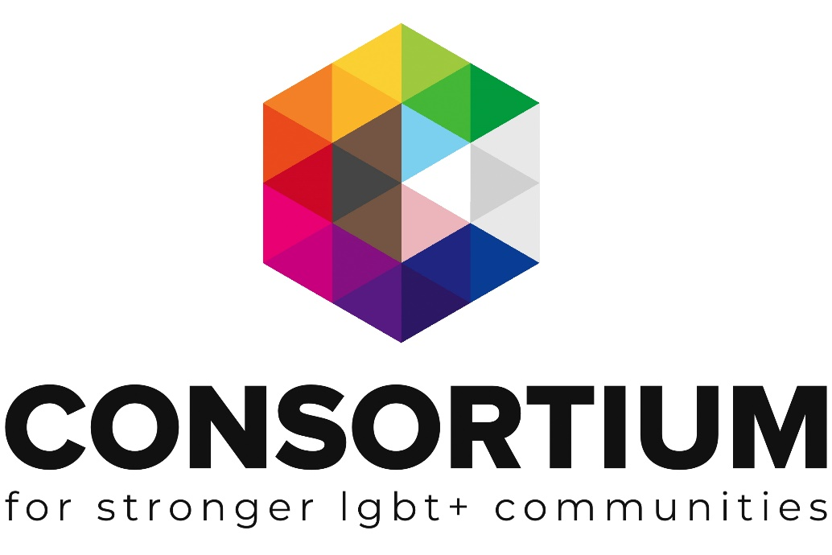

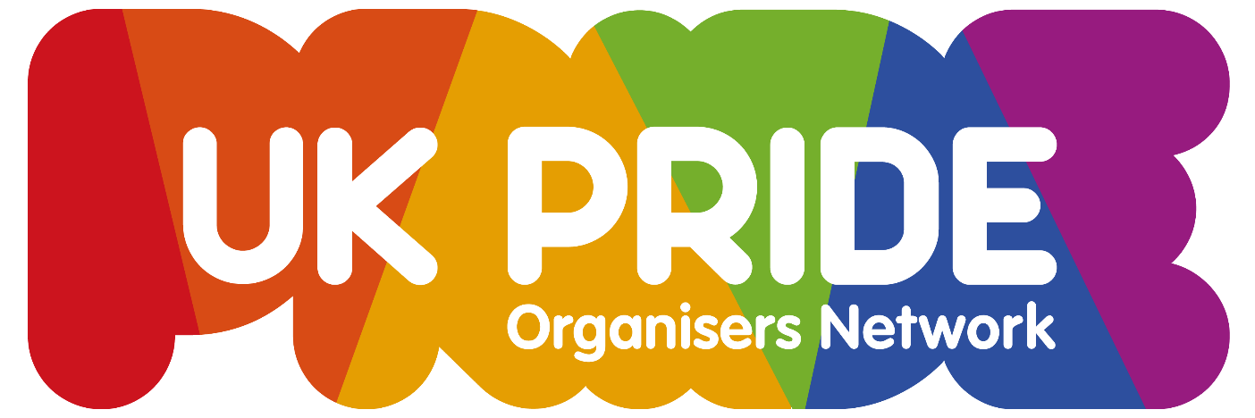
Pride Essentials
Toolkit
As part of the LGBT+ Futures Fund Programme Consortium and its delivery partners developed a range of learning and skills development opportunities.
As you work through the factsheet topics you will see a range of icons which are designed to alert you to additional information and support at the appropriate time.
Template: Click on the icon to access blank template documents for completion

Example document:
Click on the icon to review completed examples
Webinar Available. Click on the icon to take you to a recorded webinar on the topic

Additional Support Available:
Email us if you need more support or information

Important Information:
Don’t be tempted to skip a section with this icon next to it.

External Link or Resource: Clicking on this icon or a link by it will take you to an external resource or webpage

This Toolkit is not intended to be a definitive guide.
It is designed for LGBT+ groups to gain a better understanding of the subject matter.
All the information provided was up to date at the time of creation.
This Factsheet was created by UK Pride Organisers Network (UKPON) and Consortium as part of the
LGBT+ Futures Fund Skills Development and Training Programme 2019-2020.

Pride Essentials Topics
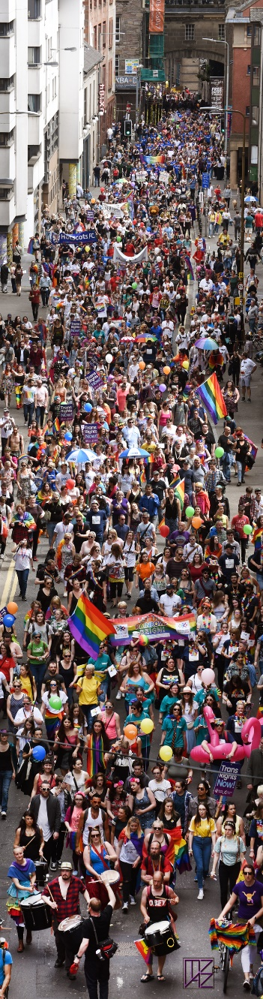
- Introduction
- Research
    - Organisation Structure
    - Insurance
    - Local Authority
- Pride Day
  - Event Management & Safety
  - March or Parade
  - Volunteers
  - Accessibility
  - Funding
  - Marketing and Promotion
  - Environmental Sustainability
  - Contingency Planning
- Working with Service Providers
  - Entertainment
  - Stalls: Retail and Information
  - Refreshments
  - Professionals
- Is Pride more than just one day?
- Feedback
- Sustainability and Succession Planning
- Useful Links
  - List of all links from toolkit
  - Additional external links
Edinburgh Pride March 2017 photo ©mazzimage.com

The UK Pride Organisers Network

Members of the UK Pride Organisers Network (UKPON) help and support each other to produce events that both celebrate and raise awareness of the ongoing challenges faced by LGBTIQ+ people. In addition to the online peer-support group, UKPON hosts meetings and workshops of interest to the Pride movement. There are opportunities to exchange ideas, to get advice on working towards best practice, and recommendations of groups and organisations that are there to help support Prides in and around the UK.

If you are planning to organise a Pride event and would like more information about becoming a Member of UKPON, please email board@ukpride.net and please send all press release information to media@ukpride.net. Together we make a difference - Together we make Pride!

Introduction

Pride is best when it is done for the community by the community, and it’s ok to start small and grow with the ideas and engagement from your local people. Ask what’s important to them and start there. Taking inspiration from other events can help but don’t be afraid to be inventive and make your Pride as unique as your people and location. Pride is both a personal celebration and a political statement supporting equality and diversity for everyone.

Before you get started there are some things to think about;
Why are you doing this and why now?
What type of event/s would be best for your community?
When is the best time of year for an event?
Where is the best location and is it accessible?
Who can help?
How much will it cost?

Work your way through this toolkit to help you answer these key questions.

Research

With a plan and the enthusiasm to start organising an event, it’s important to do some research. Start by finding out about all the legal requirements your local authorities will have for event organisers. The town or city, and county councils, as well as members of emergency services, will be key stakeholders in the success and sustainability of both your organisation and events.

There are some areas to consider:

- Which legal structure will your organisation have?
- What key roles and skills are needed?
- How will you reach out to inspire people to volunteer their time?
- How can your organisation be welcoming to people with diverse abilities or from underrepresented parts of the community?
- How will you raise and manage money?
- How can you promote and raise awareness of your organisation?
- What will the visual branding look like?
- Which local businesses and organisations could help with support and/or promotion?
- How can your organisation reduce the environmental impact of your activities?

Please access the Event Planning Checklist template to help you get started.

Organisation Structure

It is essential to ensure your Pride has the right legal structure to allow you to operate effectively and apply for relevant funding.
Use this link to access our summary factsheet on ‘types of legal structure’ and ‘registering as a charity’. If you need support with making this decision, please get in touch with the Consortium Engagement team.

Once you have established the appropriate legal structure, it is also essential to ensure you have the relevant management in place. We have listed some of the most common areas requiring attention for Pride groups below together with some suggested resources.
For further information and to ensure you have everything in order, please contact our Engagement team and access our resource library section: Running your group.
- Board of Trustees not meeting legal requirements. Trustee Toolkit (vol led)
Trustee Toolkit (staff led)

- Governing documents not meeting legal requirements. Legal structure

- Inappropriate or incomplete finance systems . Holding money & bank a/cs

- Inadequate or incorrect insurance cover. See below

Insurance

Ensuring you have appropriate cover is key at such a large public event.
You must ensure you have adequate public liability cover (as the event organisers, the policy must be taken out by your group, you cannot rely on the cover of other organisations such as a venue you may be using).

You may also require employer liability cover, which includes cover for volunteers.
Consortium membership enables you to access discounted insurance – get in touch today and talk through your specific event plans to ensure you obtain the correct level of cover. It is advisable to overestimate in terms of numbers of people expected. Remember if your Pride plans change (in terms of activities, expected numbers etc) you should inform your insurer immediately as cover may need to be updated. If you are not a member, please get in touch to find out about the many benefits of joining.

Local Authority

Making contact with representatives from your Local Authorities (LA) in a timely and considered way will be important to the success of your event. Many City/Town Council websites list an event registration form and by completing this you’ll then know the correct information they will need from you.

This is also where you’ll find out about things such as licences; for using venues, for playing music, for providing entertainment, for community fundraising (on the street or raffle tickets), for commercial traders and selling alcohol, or road closures. They can also help recommend who to contact in various departments and advise on service suppliers like waste management. There may also be environmental impact requirements such as consideration of the trees and grass plus minimising waste and promoting recycling.

Example Event Guides:
Doncaster Council - Handy Event Guide
Oxford City Council - Step by Step Guide to putting on an event
Witney Town Council - Event Guide, Witney Town Council - Event Application Form
London (Westminster) - Event Guidelines
Management Plan checklist with useful Proforma (NB document references Australian Law)
The Purple Guide to Health, Safety and Welfare at Events
Guide to Safety at Sports Grounds
Health and Safety Executive
The Music Licence from PPL PRS
Tourism and events guide Scotland
Tourism and events guide Northern Ireland

Pride Day

Most Pride events are family-friendly daytime gatherings and have a few key ingredients that vary depending on size, location, budget, volunteers, local authority requirements etc. Below are some ideas you might wish to include, but be inventive and design the event that best serves your community.

- March or Parade with a highly visible route to maintain political awareness of inequalities still faced by too many gender or sexually diverse people.

- Stage with music and performances, plus speeches.

- Stalls with a mix of community information and services, and retail shopping.

- Spaces such as; family activities, interactive games, dog shows, quiet area, etc.

- Refreshments including bars, coffee, soft drinks, ice cream and a variety of food.

- Fundraising volunteers with tins and raffle tickets, and possibly merchandise.

- After Party often a fundraiser hosted by a venue with adult-focused entertainment.

Please be kind and respectful of each other and celebrate the diversity that enhances and empowers LGBTIQ+ life in your local area, in the UK and around the world. There will always be someone experiencing Pride for the first time so it is our job to make it special.
Signs around the event can help people find what the need, such as toilets, exits, and also to be more aware of good behaviour such as a Code of Conduct

Event Management & Safety

Local Authorities usually also co-ordinate a Safety Advisory Group (SAG) of emergency services and other relevant stakeholders that provide opportunities for discussion and advice to help event organisers and can include representatives from Police, Fire Department, Highways, Licensing, NHS. Their advice can help plan and develop safe environments for those who attend or will be affected by your events.
Risk Assessments (RA) are an important process; consider all aspects of your event in detail, decide if there are any risks and what can be done to reduce the risk of harm. Risk Assessments are required for various aspects of an event, such as the event/venue, parade/march, noise and fire.

TEMPLATE: Risk Assessment

Risk Assessment - Fire

Risk Assessment - Detailed

Risk Assessment - Basic

Example Noise Risk Assessment with Guidelines

Example Event Management & Safety Plan, One-day in public park for 8K-10K attendance.
Example Event Management & Safety Plan, One-day in city centre for up to 6K attendance.

Example Event Management Plan, One-day in public park for 2K attendance.

March or Parade

The origin of the international Pride movement is that of both celebration and protest. For over 50 years the gender and sexuality diverse community has taken to the streets to raise awareness of the political and social treatment of marginalised members of society and to acknowledge success in the ongoing fight for human rights, a celebrate of the freedom to love and be loved. Whether you call it a March or a Parade it is a political statement that should empower people.

The Local Authorities and SAG will be more supportive if you plan a route with least impact to traffic, especially busses. Negotiations may not always be easy to get a route with the highest visibility so it is best to start with a well-considered plan and detailed risk assessment to ensure safety of those participating, watching and affected along the way.
Encouraging groups to register both helps you plan attendance numbers, organises order of groups and also ensures they get the information needed, including time and place, any restrictions and H&S briefings. Each group should have a lead contact and it’s helpful for them to provide stewards for their group, placed either side, front and back. Keep in mind that if you allow vehicles there will be additional safety requirements.

When people gather at the starting area, this can be an opportunity for speakers to address the parade participants, inspire them and remind them why we march. Ensure that the route is accessible and position stewards alone the route at any trip hazards like stairs and bollards. Here is a sample plan that was presented to SAG when planning a march for the first time plus a map of the route and the event. EXAMPLE: Parade Plan and Site Map
Using online booking forms like Google Drive are the easiest way to collect and manage information. Before that we used forms returned in the post or via email such as this example Parade Booking Form

Volunteers

Pride is all about people and the volunteers are at the very heart of a successful event. Some will be there throughout the year during the planning, then more are needed for the events. Recruiting and maintaining volunteers enthusiasm is one of the most valuable resources your Pride should nurture and mentor. There are many opportunities for knowledge, experience and skills to be both shared and developed but it is often the time spent with others growing social networks that will sustain committed volunteers.
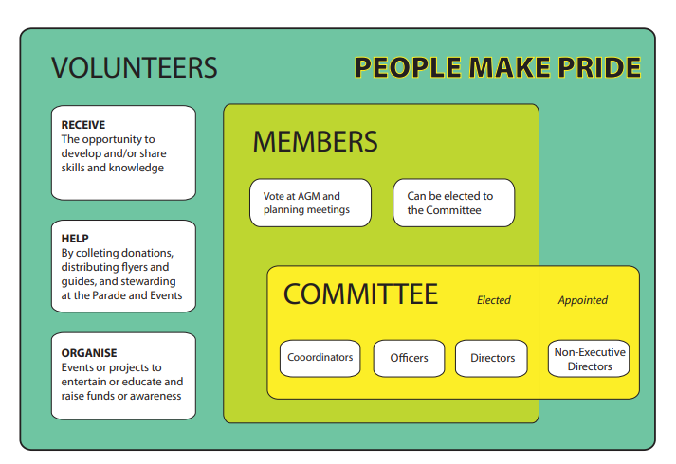
Collaborating with other organisations builds a stronger sense of community and many Prides liaise with local groups to share volunteers and to reach potentially excluded groups. Working with existing organisations, such as local youth groups also means they will already have people in place with the specific skills and qualifications needed to deal with any matters that may arise such as safeguarding issues. Some sponsors may also have staff available to volunteer as part of their mentoring or social enterprise community engagement.

Good practice resource from The National Council for Voluntary Organisations
An example of a Volunteer Engagement Programme and Code of Conduct.
Volunteer Registration forms collect personal information and how it is used has legal implications so it’s important to have a GDPR Statement.

Accessibility

Your event may need additional access for people with a range of different disabilities. Keep this in mind when planning to use venues or other locations. This may include not just physical access for toilets, stage viewing areas, parade route but other accessibility areas such as BSL signing, youth, faith or sensory areas.

When designing websites, graphics and print material there are some useful guidelines to help - click here to access the guide.

Asking for advice is always welcomed by those who want to help. Partnering with other organisation who have the experience and certification to assist is often the most success solution. The Youth Inclusion in Prides toolkit provides useful information, references and case-studies. Consider also contacting ParaPride, Deaf LGBTQIA, Attitude is Everything or Enhance the UK.

Funding

Most Prides offer free events; from the street marches to the celebration events. Unfortunately, most people don’t realise the true cost of putting on events so collecting donations on the day rarely raises more than 20p/person. Core costs to meet legal requirements and an ever-growing wish list that needs a lot of fundraising, all contribute to the difficult job of setting budgets, juggling cash flow and ensuring a sustainable future.

Choose your sponsors carefully to ensure their ethos is the same as yours when it comes to inclusion and diversity. There is a feeling within some parts of the community that the presence of large corporations in parades and at the events detracts from the political and human rights origins of the Pride movement and is just giving in to commercialisation. Getting the balance right is important and many members of the Network have stories to share.
Sponsorship can be split into different tiers for various requirements, such as these examples:
Swindon & Wiltshire Pride Sponsorship Pack
Warwickshire Pride Sponsorship Agreement Bronze, Silver, Gold, Platinum
For further information on developing corporate relationships, click here for a 30min webinar.
Raffles are a fun way to make money (people are more likely to buy tickets than just donate) and to engage with local businesses (who provide prizes). Below are some other ideas:

Fundraising Action Plan
Choosing your fundraising methods
Funding Sources for Local Groups
Marketing and Promotions

What are the most effective ways to let people know what you’re planning so they come?

A strong logo and branding is important so people recognise your promotions. Social Media is an invaluable resource for engaging with new people and promoting activities. It’s also important to remember that not everyone has easy access to the many online platforms, or for example, they may not feel safe looking at LGBTI+ content online at home. Printed material, such as flyers, posters and booklets like a Pride Programme, can help reach out to other people if distributed in a variety of locations like cafes, shops, colleges, community notice boards and surrounding towns or villages.

Producing a regular Newsletter that people can subscribe to will help keep everyone informed and interested in your activities, and can be used to promote sponsors and supporters.
Local radio shows, TV and newspapers can help share press release information to raise awareness. Be sure to send any information directly to UKPON via media@ukpride.net

Build the excitement in the lead up to your event and if you can, have a dedicated social media person at the event using all available online channels. Adding content during the day, especially photographs, videos and live streaming can create even more interaction. Consider also having a unique hashtag, for example, #YourPride2021 #YourTheme. This will also provide great content to look over, share and to show sponsors when planning next year!
An example Press Release - highlighted text has additional notes
Implementing a Social Media Plan
Top 10 Facebook Page Essentials

Environmental Sustainability

We all have a responsibility to the world around us and the way our actions impact upon it. Pride organisers have an opportunity to inform and educate people not only about LGBTI+ matters but also other global issues such as Climate Change. The original Rainbow Flag designed by Gilbert Baker assigned a meaning to each colour and Green is for Nature.

Pride organisers, like many in the event industry have been working toward more eco-friendly processes from doing more online to minimising waste. There are more resources being developed to help us consider different ways to run events and to work with our communities to raise awareness. Plastic is not the problem, the way we use and manage it is.
Here are some Principles for sustainable events from Events Industry Council.

Contingency Planning

We all want to believe that everything will go to plan. Unfortunately, that is not always the case. Sometimes anticipated funding doesn’t arrive, a sponsor or performer may become unable to fulfil their agreement or something completely unexpected may happen. It can be helpful to have a Plan B in place in case your event needs to be modified.

It can be a very difficult and emotional decision to make, but for the health and safety of people involved, it may be necessary to postpone or cancel the event. This may be the best risk management solution for your organisation and could be covered by your insurance.

Working with Service Providers
The UKPON members online group is a great resource to discuss ideas, ask for advice and recommendations. Contact the board@ukpride.net to find out more about joining.

Entertainment

When organising Pride, finding and booking entertainment can be a daunting task but it just needs a good balance between performances, DJ/music and an appropriate host. Playing music between acts can encourage people to move around to other parts of the event site and a good host can help share information with the audience, and cover any gaps when there is a tech issue (that will inevitably always happen).

Always book entertainment that is suitable for your event, eg: audience appeal Vs capacity of venue, and a daytime family event is a very different audience to an adults-only evening show. Local performers are usually very supportive and will often perform 'for expenses’ such as taxis to/from the event. Treated well they’ll help promote and enhance the event even more.

Always get everything in writing to minimise any potential misunderstandings. Confirmation of time and date, of course, but also ask, “What are the technical requirements?” Bands and Live performers need setup time and might need a technical rehearsal, and backing music can come in different formats. You'll need to confirm vehicle access to dressing rooms plus the pre-stage Greenroom (preferably with toilet and mirror) and post-show expectations or hospitality.

Contracts from agents/managers can be complicated - Beware of ‘Riders’. These are a type of backstage hospitality often set by the agent and can range from a bottle of water to an extensive list of hot and cold foods, drinks, premium alcohol, personal items for the performer and their entourage. These are optional and you should not feel pressured to provide more than what your team agree is appropriate.
EXAMPLE: an Artist Agreement and a Code of Conduct.

Stalls: Retail and Information

Many people attend Pride to access information and to buy something special to remember their day. Providing a good variety of community groups, unions and LGBTI+ organisations plus commercial traders will enhance your event.

Online registration forms can help gather all the information required so you can choose who you’d like to attend your event, including contact details, planned activity, insurance details.
When designing your site map remember that the groups run by volunteers distributing information are likely to pack up early leaving either a vacant stall or empty pitch if they brought their own. Commercial traders will stay for the duration of the event as will food and drink suppliers. With these people working long hours and often unable to leave their stalls for long, it is also helpful to provide either designated or priority access to toilets.
EXAMPLE: Stall Booking Information and Guidelines

Refreshments

Most events now provide a selection of different refreshments to help keep people at the event. In addition to typical ‘festive food’ being offered, consider vegetarian, vegan and healthier options, also ice-cream, tea & coffee and soft drinks in addition to bars.

Food and Drink suppliers will be required to provide additional information to local authorities to meet health and hygiene standards. Bar operators will also require a licence to sell alcohol. It is important to know what is needed by the local authorities so that these can be asked for within your online ‘Catering expression of interest forms’. Businesses that regularly work at events will have all their paperwork ready. EXAMPLE: Details required from Caterers.

Some Prides put a call out for Tenders to run catering thereby enabling the best offer to be used. Others run their own food stall or bar with Volunteers. This can raise a lot of cash therefore requires strong supervision and control measures.

Prides and local authorities are increasingly requiring food and drink traders to minimise waste with recyclable or reusable containers. The type of the business you choose to include at Pride can help not only your event but also the local community and environment.

Professionals

In addition to working with a great team of volunteers, experienced professionals are needed for important logistical areas and can take a lot of the stress away from organising the event. Local people can be a helpful resource for recommending trusted suppliers so it’s always useful to ask for advice and do ensure they understand the demographic of your event.

If they are good, they are likely to get booked well in advance. Ensure you make contact at least 6 months before the event. Security, First Aid, Stage and Lighting, Marquees and Structures, Unisex Toilets, Waste Management, Traffic Management just to name a few. Some will require more time, such as BSL interpreters who need to coordinate a team to meet the requirements of your event.

Also ask about their sustainability processes, such as supply chain, how they manage waste and what do they do to minimise environmental impact of their business. We all have limited resources and should make the best use of them.

First Aid Request Form - Yorkshire Ambulance Service, First Aid Request Form - EMC

Is Pride more than just one day?

Pride brings people together and can be a unique focal point for a diverse range of people.
To help generate interest and enthusiasm in your Pride there are additional opportunities to hold events that raise awareness through education, entertainment and other social gatherings. These can be in person or online reaching out across different social media channels to engage and support your local community.

Pride Week is often the lead up to your Pride Day and can help bring people with a shared interest together, such as a dog show, coffee and cake social, panel discussion, art and craft exhibition, walking tour, pub quiz or karaoke. Look at what exists around you, such as a youth group, a book club or faith groups, then invite them to get involved or just ask what others would like to help organise. It’s surprising how many people just want to be asked to help.

Regular events throughout the year can help build a sense of feeling connected and reduce social isolation for those at different stages of their personal journeys. Online groups and activities across social media channels and social gatherings in a variety of locations can give people different opportunities to find and develop new friendships, and enjoy more Pride.

Feedback

Reaching out to your community to get feedback on what they enjoyed and valued most about your activities will help you plan for the future. Online surveys work well. This is also valuable information for potential funders and sponsors and will help you plan for a successful future.

Sustainability and Succession Planning

Many thousands of dedicated people have volunteered their time and resources to start, grow and develop Pride events around the globe. It's not just people in the big cities, now those in towns and villages also bring local people together with Pride. Some do it for a year or two, others for decades and some even get paid for part of the work they do to continue this valuable human rights movement. By welcoming and mentoring new people we share a vision to make the world a better, more diverse and friendlier place for everyone.

Encouraging others to become actively involved and join this journey is key to the sustainable success of your Pride. Reaching out to people with professional skills, those from underrepresented parts of the community and collaborating with other groups will provide a strong foundation and development of your organisation. It's not always about growing the size of the event, it's about doing the best for your community, with your community.

All organisations have their ups and downs; they say challenges are opportunities, and organising a Pride event will provide many of these. The UKPON online group is there for you with a wealth of knowledge and experience, so you need never feel alone on this important journey. UKPON is an associate member of European Pride Organisers Association (EPOA), InterPride and ILGA Europe who all offer a wealth of resources online.

Since 2016 members of the UK Pride Organisers Network have voted on who will host the annual UK Pride. The host Pride welcomes all people, especially from other Prides, to share in this national celebration and to be visible in a show of solidarity for those people who are unable to live with the freedom to love or be their true self.

Please get in touch to find out more about joining UKPON by emailing board@ukpride.net

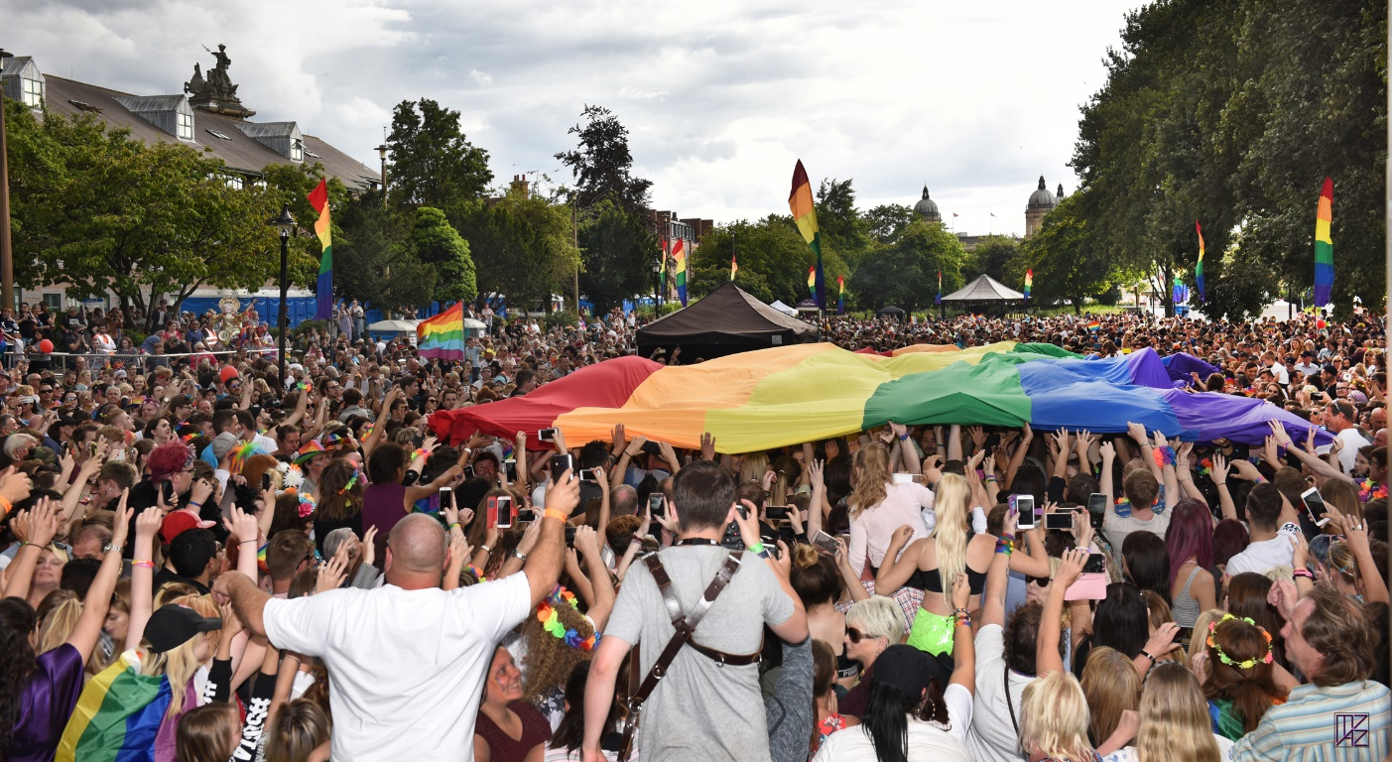
Rainbow Flag at UKPride 2017 hosted by Pride in Hull - photo ©mazzimage.com

Links

Summary of all links and resources detailed within this toolkit

Event Planning Checklist
Trustee Toolkit (vol led)
Trustee Toolkit (staff led)
Legal structure
Holding money & bank a/cs

Doncaster Council - Handy Event Guide
Oxford City Council - Step by Step Guide to putting on an event
Witney Town Council - Event Guide
Witney Town Council - Event Application Form
London (Westminster) Event Guidelines
Management Plan checklist and guide includes useful Proforma
The Purple Guide to Health, Safety and Welfare at Events - £25+VAT subscription fee pa
Guide to Safety at Sports Grounds
Health and Safety Executive
TheMusicLicence from PPL PRS
Tourism and events guide Scotland
Tourism and events guide Northern Ireland

Code of Conduct
TEMPLATE: Risk Assessment
Risk Assessment - Fire
Risk Assessment - Detailed
Risk Assessment - Basic
EXAMPLE: Noise Risk Assessment with Guidelines
EXAMPLE: Event Management & Safety Plan, One-day in public park for 8K-10K attendance.
EXAMPLE: Event Management & Safety Plan, One-day in city centre for up to 6K attendance.
EXAMPLE: Event Management Plan, One-day in public park for 2K attendance.
EXAMPLE: Parade Plan
EXAMPLE: Site Map
EXAMPLE: Parade Booking Form
The National Council for Voluntary Organisations
Volunteer Engagement Programme
Volunteers Code of Conduct
Volunteer Registration forms
GDPR Statement

Dos and don'ts on designing for accessibility
Youth Inclusion in Prides toolkit
ParaPride
Deaf LGBTQIA
Attitude is Everything
Enhance the UK

Pride Sponsorship Pack - Swindon and Wiltshire Pride
Warwickshire Pride Sponsorship Agreement Bronze, Silver, Gold, Platinum
Corporate relationships

Fundraising Action Plan
Choosing your fundraising methods
Funding Sources for Local Groups

Press Release
Implementing a Social Media Plan
Top 10 Facebook Page Essentials

Gilbert Baker Rainbow Flag
Events Industry Council

Artist Agreement and a Code of Conduct

Stall Booking Information and Guidelines
EXAMPLE: details required by City Council from Catering Suppliers

First Aid Request Form - Yorkshire Ambulance Service
First Aid Request Form - EMC

European Pride Organisers Association (EPOA)
InterPride
ILGA Europe

Additional / external links:
Event Health and Safety
Event safety

Running community events guide
https://www.visitscotland.org/events/advice-materials
Temporary Events Notice
Entertainment Licenses

Charity Commission
Charities and social enterprises
Set up a charity: step by step
Guidance

Safeguarding
Safeguarding and protecting people for Charities and Trustees
NSPCC Learning Scotland
NHS England Safeguarding Team
Safeguarding Ireland

Government
Disclosure & Barring Service

Environment
Brighton Pride sustainability pledge
Greener Pride (USA)
Environmentally Friendly Pride
eventIMPACTS toolkit
The Rubbish Project
Some interesting ideas in Sustainable Events from Event Industry News

We would value your feedback on this Pride Toolkit to ensure it stays useful and relevant in our changing world. This Toolkit has been developed with assistance from many Pride organisers and we hope it helps inspire many more.

Pride Organisers at UKPON 2019 AGM & Conference hosted by Doncaster Pride - photo ©mazzimage.com
