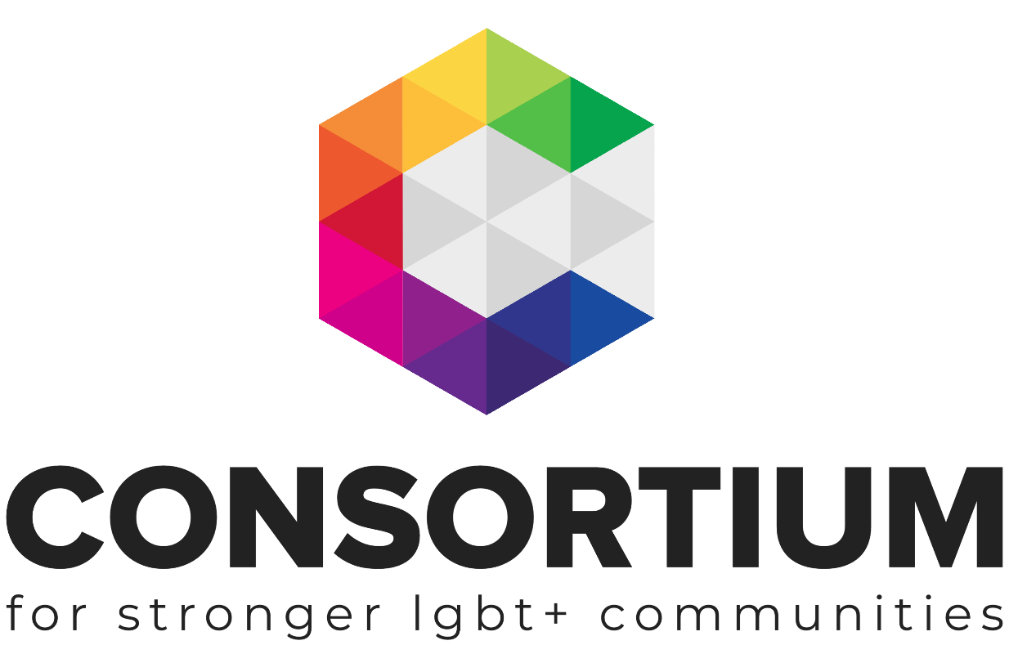
Fundraising
From Grant Makers

LGBT+ Futures Programme Workbook

As part of the LGBT+ Futures Fund Programme, Consortium and its partners are delivering a range of learning and skills development opportunities.

These online toolkits are designed for LGBT+ Groups and organisations to work through with key volunteers, staff or Trustees to develop key policies, procedures, plans and management techniques.

As you work through the toolkit you will see a range of icons which are designed to alert you to additional information and support at the appropriate time.

Group Activity: Get your volunteers, colleagues or Trustees involved in this part of the toolkit

Additional Resources Available: Ctrl + Clic on the icon or nearby link to take you to a resource to find out more information the topic

Webinar Available. Ctrl + Click on the icon or nearby link to find a recorded webinar on the topic you are learning about

Additional Support Available: Email us if you need more support or information on a topic

Important Information: don’t be tempted to skip a section with this icon next to it.

External Link or Resource: clicking on this icon will take you to an external resource or webpage

This Toolkit is not intended to be a definitive guide or template.
It is designed for LGBT+ groups to work through a series of activities and information in order to build a better understanding of the subject matter.
All the information provided was up to date at the time of creation.
This Toolkit was created by Consortium for the LGBT+ Futures Fund Skills Development and Training Programme 2019.

Contents

Section 1: Get Fit for Funding
- Getting the basics right
- Finding your Funder
- Preparing a Project

Section 2: Writing successful Funding Bids
      - Developing a project
- Evidencing need
- Setting Outcomes

Getting Fit for Funding

Like everything else, fundraising is more effective if there is a solid foundation to start from. Your group will find it easier to generate income if it has basic structures and systems in place. However, most of these improvements can happen alongside your fundraising – don’t wait until everything is perfect before you start fundraising!

Checklist
Work through the following checklists to see what you have already got in place and what gaps you might have to work on.
Your Team
- Trustees who can think and plan strategically
- At least one person with good writing skills
- At least one person who is a natural networker / relationship-builder
- People in roles that best suit their skills
- People willing to learn and to adapt
- An understanding of fundraising across your team, with everyone willing to take part

Use this space to make a note of anything that you need to work on or put in place to make sure you have the right people on your team.

Paperwork:
Each funder will ask for something different from you if you are applying for a grant but there are a few essentials its good to have in place before you start.
- A Constitution or Terms of Reference for your group
- A Fundraising Strategy that fits with your Strategic Plan (more on this later!)
- A Communications Plan that supports your fundraising
- A set of policies, including Equality & Diversity, Health & Safety, Financial Management, Managing Volunteers, HR (if you have paid staff), Data Protection, Complaints, Safeguarding

Use this space to make a note of anything that you need to work on or create to have the right things in place.

Finances:
Again, if you are applying for a grant then each funder will have different demands from you but it’s a good idea to have the following in place for your group before you undertake any kind of fundraising.
- A bank account for your group, with at least two named signatories
- An accounting / book-keeping system – a way of recording and keeping track of income and expenditure, even if this is just Excel-based
- An accountant if you need to produce end of year accounts
- Agreed ways of dealing with expenses, donations etc. Ideally, written policies on these things
- Insurance – Public Liability for delivering services and events; Employer Liability for staff and volunteers.
Use this space to make a note of anything you that your group needs from the list above.

Find Your Funder
If your group has decided to raise funds through applying for grants then the first step is identifying who you will be applying to.
If you intend to create a Fundraising Strategy (can be a very simple document) then listing the dates and lead up times for applying for each funder you indentify can be a useful timeline to work against.

You can search for funders in a variety of ways:
Use an online grants directory (ctrl+click links):
- Fundingcentral.org.uk is free for organisations with income under £100k, otherwise by subscription;
- GrantsNav is a free, searchable database of grants given by almost 100 UK funders;
- Grantsonline is a free searchable directory;
- Consortium’s Funder Finder is a growing list of funders that we know to have given to LGBT groups.
Paid-for directories include
- trustfunding.org.uk,
- grantfinder.co.uk
- fundinginformation.org.uk

You may be able to access at least one of these for free via your local CVS support organisation, local authority or library. Libraries often have printed copies.

Search for grants via Google: This is more time-consuming than using a directory, but can still be fruitful e.g. search ‘Grants for LGBT groups’ or ‘Grants for youth projects’ or ‘grants for community projects Manchester’…

Sign up for grant alerts: Your local authority or CVS support organisation may periodically send out emails with details of funders and grants.
Check out similar organisations: Have a look at organisations doing similar work to you to see who funds them. You can look at their website and/or their accounts on the Charity Commission (ctrl+click) website, if they are registered.

Once you have identified your funders, it’s important to tailor your application to the funder’s interests. Tailor each application to the funder’s stated interests and criteria rather than sending an identical application to several funders e.g. If a funder is interested in health, ensure you highlight the aspects of your project that promote good health and wellbeing; if a funder is interested in a geographical area, apply only for work in that area; if a funder only supports capital costs (buildings, equipment), do not ask them to fund the revenue (running costs) of your project.

Take time to ensure it’s a good fit for your group and the funder.
Have a look at the funder’s website to discover their:
- Specific interests and grants criteria
- Type of organisations they usually give to
- Typical grant size
- Deadlines and how long you’ll have to wait before receiving a response

Read all information carefully and only apply if you feel your organisation and project are a good fit otherwise you risk wasting your time and frustrating the funder.

You could also look at the funder’s record on the Charity Commission (ctrl+click) Register (for charitable trusts and foundations based in England & Wales, otherwise the Scottish Charity Register or the Charity Commission for Northern Ireland). Look particularly at their recent accounts, which may include details of grants given in the previous few years. You could also contact the funder if you have any remaining questions.

Preparing a Plan
Most funders, unless they explicitly state otherwise, want to fund distinct projects rather than simply contributing to your groups ongoing or running costs.
It’s a good idea to have a clear project plan before you start applying, and to produce a clear written description of your project or need. This will help you think through all aspects and gather the information needed.
Your plan should Include:
- Details about why the project is important:
What’s the need your project meets? Do you have facts, statistics, case studies, quotes to demonstrate the need? If you are applying for a staff cost, why is this role vital?
- A clear description of what activities you will carry out
Provide a detailed account of your project that allows anyone reading your bid to create a mental picture and which answers all of their questions e.g. If you are running support sessions: how many will you run and over what time period, how long is each session, how many people will attend each session….?
- A clear set of outcomes
What changes will your project bring about? How many people will you reach and how will you monitor progress and measure success? E.g. If group participants will improve their mental health, can you measure this with a questionnaire at the beginning and end of your project? Aim for 3-5 outcomes per project.
- A detailed breakdown of how much your project will cost
Put together a simple budget itemising the costs of staffing, materials, venue hire…and all other costs. You can include a management cost to cover overheads but keep this relatively low e.g. no more than 10% of your total project cost.

Writing Successful Funding Bids

Each funder will ask your group for different information in a different format. But don’t be tempted to copy and paste stock responses.
Here is a simple list of things to think about when writing a funding bid.

- Read any guidance produced by the funder, then read it again.
- Be clear and concise, funders want to understand what you want to do, why you want to do it and how you are going to do it.
- Don’t expect the funder to know all about you and what you do
- Provide evidence to back up why you think the project is needed
- Get someone who is not involved in your group to read over your finished bid, if they get it, then you’re on the right track.
- Check deadlines and then check them again

Watch a short webinar (10 minutes) to find out more about writing funding bids.
Ctrl+ Click here to watch the video (link takes you to our You Tube channel)

Evidencing the Need
Every Funder wants to understand why your project is needed. It’s up to your group to clearly communicate and provide evidence of why you believe the work you will do is needed, and why you think it will work.
Where to find evidence...
- National LGBT Survey
- Evidence from your own work
- Other similar projects that have been successful
- Consultation exercise with group users
- Research
- Other LGBT groups and organisations

How do you know there is a need, what evidence can you offer e.g. research, reports or studies that back up your claims (don’t forget the National LGBT Survey)

How do you know that your proposed project is the way to meet that need?

How have you included the people who have that need in working out how you will address it?

Any research or data is good but human stories are better – funders are confronted with applications full of stats every day!

Setting Outcomes for your Work
There is a set of words used in most funding applications that it helps to have a clear understanding of, in order to set your outcomes.
- Activities
- Outputs
- Outcomes
Activities
Are the practical things you will need to do to make your project or work happen
Outputs
Are the number or volume of things that happen (Outputs measure, they don’t address change or value)
Outcomes
Are the changes that will happen as a result of your outputs or work

To set your outcomes for a project you need to identify the problem you want to tackle then the change you want to see. Outcomes should always be:
- in line with your organisations overarching aims
- realistic and achievable
- measurable

What are the over arching aims of the organisation? It’s important to remember these when setting your outcomes, as they should be in line with helping your group to achieve its aims.

How do you currently measure your work?
What might you try for your next project?

To better understand some of the language, processes and methods used around outcomes and how to measure the changes your work is making, we have created a short 20 minute webinar. Ctrl+ Click here to watch the video (link takes you to our You Tube channel)

As you have worked through this Toolkit you will have gathered all the information you need to create your own plan, policy or information pack. Most Toolkits have templates which you can download and transfer the relevant information from the Toolkit across to, so that you have your own bespoke piece of work for your group.

If your group needs any further support around the topic covered in this workbook please get in touch with our Engagement Team via email admin@lgbtconsortium.org.uk.

To find out more about Joining Consortium, visit our website for more information.

