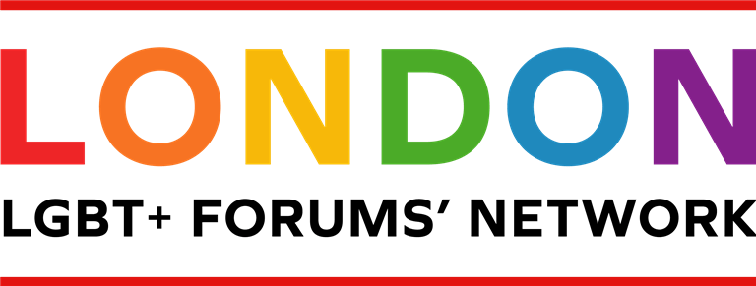
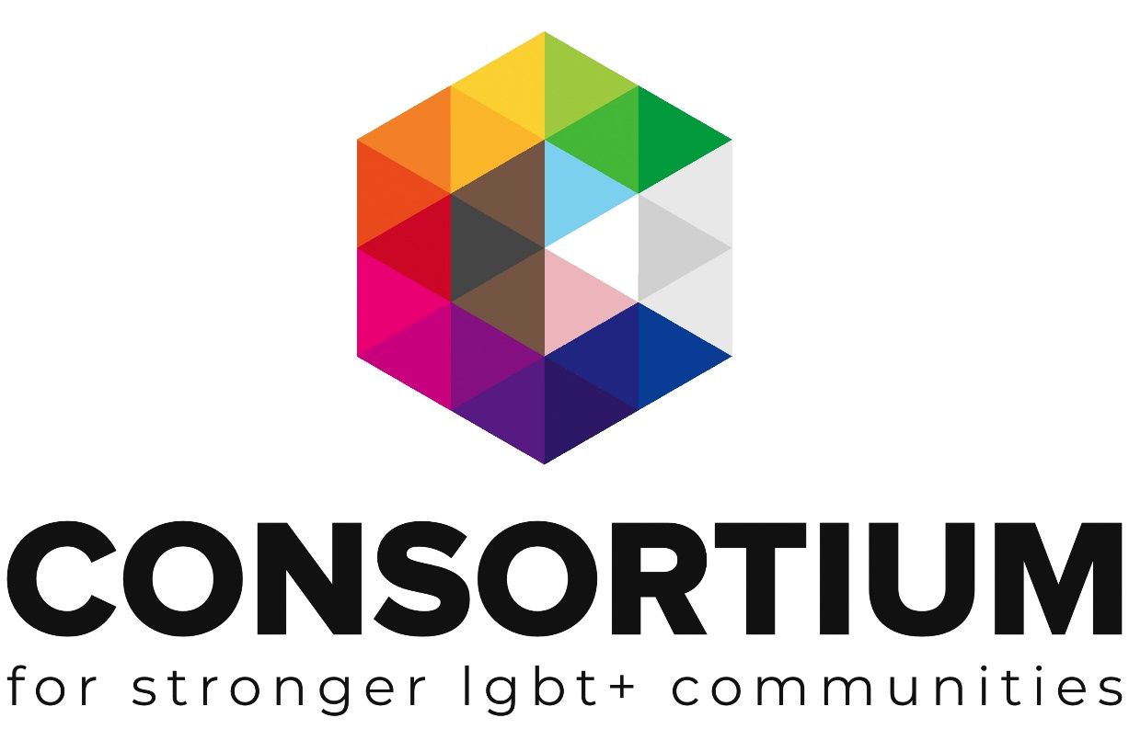
LGBT+ Forums

These online toolkits are designed for LGBT+ Groups and organisations to work through with key volunteers, staff or Trustees to develop key policies, procedures, plans and management techniques.

As you work through the toolkit you will see a range of icons which are designed to alert you to additional information and support at the appropriate time.
Group Activity: Get your volunteers, colleagues or Trustees involved in this part

Additional Resources Available: Click on the icon to find more information on the topic

External Link or Resource: clicking on this icon or a link by it will take you to an external resource or webpage
Important Information: don’t be tempted to skip a section with this icon next to it.
Webinar Available. Click on the icon to take you to a recorded webinar on the topic

Additional Support Available: Email us if you need more support or information

This Toolkit is not intended to be a definitive guide or template.
It is designed for LGBT+ groups to work through a series of activities and information in order to build a better understanding of the subject matter.
All the information provided was up to date at the time of creation.
This Toolkit was created with The London LGBT Forums Network working group 2020.

Contents

Introduction
Support
Purpose
Changing legal structure
Rebranding
Promotion
Insurance
Finances
Funding
Policies
Volunteers
Safeguarding
Diversity
Monitoring & Evaluation
Conflict management
Continuity

Introduction

This toolkit has been developed to support existing and established forums to ensure their long-term sustainability. This is particularly important where there may be key people driving the forum’s success, to ensure continuity if they step down from their role.

There is no ‘fixed way’ to run a forum and the information below is based on input from The London LGBT Forums’ Network working group based on their experiences. Each section provides a brief overview of the topic and links to more detailed information.

If a section does not feel relevant to your situation, just move on to the next topic. Though do keep in mind, any sections marked with the ‘important icon’ should be considered by all.

Support

Remember you are not alone!

If your forum is facing a difficult challenge, it’s likely that other forums have faced something similar and so peer support can be invaluable to help navigate through issues. A good starting point is to view the London Forums map to get in touch with neighbouring borough forums or contact The London LGBT Forums’ Network: LondonLGBTForumsNetwork@outlook.com

The Consortium is also here to help, with an extensive range of resources, training, access to our Funder database, discounted insurance and 1:1 support for our members. Please access the members dashboard or get in touch with the engagement team for support.

Purpose

As forums develop over time, their initial purpose and aims may change, so it can be helpful to revisit this with your committee members and ensure your forum continues to serve the community. You may decide to review as a one off, or it may be useful to agree a regular review period such as once a year.

This can also be a good opportunity to plan ahead and consider your forum’s future direction. Forums seeking to develop a formal strategic plan can request our toolkit using this link.

These are some of the key areas identified by groups within the main themes of:
Health, Safety and Culture

Tick all those that are relevant to your forum and add any others that are not listed. Are there any areas you would like to start delivering as part of your forum’s continued growth and development?
Return to Index
To liaise with your local authority on LGBT+ equality matters. *

A link between LGBT+ community members and partners.

A link with the local police / hate crime coordinator.

Providing social opportunities for the local LGBT+ community.

Hosting events / Prides to raise the profile of the LGBT+ community in your area.

Organising and running support service groups (often more relevant to well-established forums).

An information ‘hub’ sign-posting to opportunities, services and provisions.

Other areas of focus

*Remember it is important to remain party-political neutral regardless of personal/individual views in to order to best represent local borough communities and build effective working relationships with your local councillors, London Assembly Members and MPs.

As part of the review process, it can be a good opportunity to revisit your forum’s key vision, mission and values. Click here to access a brief activity sheet.

Changing legal structure

When your forum first launched, you may have opted for an informal unincorporated structure to best suit the start-up phase. Now that your forum is well established, it may be helpful to consider changing the legal structure if you are seeking to expand your forum’s offer and services delivered, employ staff or to be able to access grant funders who require specific structures.

If your forum would like to find out about incorporated structures, please take a look at these resources:

Guidance Tool Legal Structures
Choosing a legal structure
Registering a charity

Forums preferring to remain as an unincorporated association, please note Trustees take on personal liability and shared responsibility for the group’s actions. In addition, unincorporated groups with charitable aims and a regular annual income of £5000 or more should register with the charity commission.

You may feel that you have the right legal structure, but that it is time to update your Constitution to reflect any changes to the forum’s remit.

Consortium can support members with these changeover processes, please get in touch with the engagement team for guidance.

Rebranding

Long-standing forums may decide that it is time for a rebrand. This may be particularly relevant to forums where the main aims / purpose have changed over time and you want the brand to reflect this. Or it may be to update terminology, for example from LGBT to LGBTQ, or LGBT+ and so on.
Return to Index
For more information on the rebrand process please access our factsheet.

Promotion
If a forum has been running for a significant period of time, it can be useful to complete an audit of your promotional activities, in order to ensure they are up to date and relevant. It can be a good opportunity to delete old / inactive social media accounts, blogs or websites.

It is also helpful to record login details and ensure these are stored by at least 2 forum colleagues to provide continuity of access.
Record below your social media and other promotional platforms (such as local papers) and any actions required (such as delete, update content, relaunch etc).

For further information about getting the most out of social media, please access our resources:

Facebook essentials
Getting the most out of twitter
Implementing a social media plan

Social media can be a great way to promote your forum, but it can also be a daunting environment for volunteers with no specific training or background in PR. To avoid potential issues (such as getting embroiled in a conflict with social media trolls) it can be useful to put in place clear guidelines to outline what is and is not acceptable including the distinction between the use of forum social media and personal accounts. Please get in touch with our engagement team for support with developing a social media policy.

Insurance

If your forum is delivering services, it is important to ensure you have the right cover in place. Consortium members can access discounted insurance via the members dashboard.

Finances

As organisations grow it is useful to review existing finance systems and consider if any changes, adaptions or additional protocols need to be put in place in order to manage and monitor a larger income.
Return to Index
For support to review your current systems, please get in touch with the engagement team for guidance.

For further guidance on finance best practice, please access this short webinar.

Funding

For the ongoing success and sustainability of your forum, it is essential to ensure you are able to fund the activities that you deliver.
Consortium has a wide range of resources including factsheets, toolkits and webinars to support groups with fundraising.
Below are some of the key resources and the full range is available via your membership dashboard.

Fundraising Factsheets:

Fast Fundraising Ideas
Types of Fundraising - a brief overview of seven key fundraising options

Fundraising Webinars (short subject tasters)
Developing corporate relationships
Fundraising from Grant Makers

Toolkits
For groups keen to explore this is more depth we have two focused toolkits which can be ordered:
Developing a fundraising plan
Fundraising through grant makers (bid writing)
Consortium members can also access our Funder Finder: a directory of funders that we know are supportive of LGBT+ groups and organisations.

Policies

There are some key policies that you really should have for your forum covering topics such as safeguarding, inclusion and diversity and data protection.
These policies should be in place to protect both those running the group, and those using the support, services or events offered by the events. Below is a list of some of the essential policies all voluntary led groups should have, and then a list of policies that it would be good practice to have (if relevant).

Essentials

- Health and Safety
- Inclusion and Diversity
- Data protection and privacy
- Complaints
- Volunteer policy
- Safeguarding policy
Return to Index
Others

- Financial management
- Bullying and Harassment
- Conflicts of Interest
- Reimbursing Expenses and Purchases
- Whistle Blowing
Consortium can support members to develop and adapt their policies. Please get in touch for support.

Volunteers

Volunteers are essential for the effective running of forums and so it is important you have a Volunteer Policy in place and effective systems to recruit, support and retain your volunteers as well as managing any conflicts or issues.

Watch this brief webinar on developing your volunteer programme and access our Top 10 volunteer essentials resource here. Full resources including a volunteer programme toolkit are available via the Consortium membership dashboard.

Safeguarding

For any group connecting with members of the public, it is important to have a basic understanding of safeguarding. And if your forum delivers any services for children (defined as up to the age of 18) or vulnerable adults then it is important to have a safeguarding policy in place proportionate to the service you deliver.

For the purposes of safeguarding:
Vulnerable adults are defined as individuals aged 18+ who are, or may be in need of community care services because of their:

  - mental health
  - other disabilities
  - age
  - illness
  - A person who is or may be unable to take care themselves
  - A person who is unable to protect themselves against serious harm or being taken advantage of
Your local Safeguarding Board coordinates all local work to safeguard and promote the welfare of children and vulnerable adults and also provides training (usually free) to any individuals who work with children/vulnerable adults. The Board are also there to advise and do keep in mind that at any point if your forum has a safeguarding concern, a query or even if you are clear on what to do but you just want reassurance – you can contact them!
Return to Index

A simple internet search of ‘safeguarding board (your borough)' will take you to the relevant website.

Consortium has produced a comprehensive toolkit to support groups to develop a safeguarding policy and those wishing to review/audit their existing policy. Click here to request the toolkit.

If you already have a Safeguarding policy and procedures in place it can be a useful exercise to carry out a review. Please access the audit tool here

Diversity

There is unfortunately often a lack of diversity with committee representation and indeed broader public involvement. It is therefore important to explore ways to ensure you are reaching diverse communities.

As a starting point it can be helpful to review your forum’s public information (website, social media and so on) and ensure that language and imagery is fully inclusive. It can also help to link with relevant groups who work with the communities you wish to reach (such as trans groups, BAME/POC groups, older people groups and so on) to ensure your forum information is promoted as broadly as possible.

The Consortium has a number of webinars on inclusion:

Disability inclusion webinar
Including older people
Including people of colour
Trans inclusion

Monitoring and Evaluation

Monitoring and evaluation is a continual process and relates to all aspects of your forum’s work, from evaluating a specific project your forum has delivered to ongoing monitoring of your membership.
Measuring and demonstrating change and impact (evaluation) is particularly relevant when applying for grant funding and to be able to report to your membership on your annual impact. Watch this brief webinar on measuring impact

The Consortium in collaboration with a range of LGBT+ groups has developed an Outcomes Framework. It seeks to act as an initial reference point for organisations to critically reflect on what outcomes they are best placed to achieve and potential areas of collaboration with others. For further information about the Outcomes Framework, please use this link.
Return to Index

Conflict Management

Unfortunately, situations may arise where there are conflicts between forum committee members, such as with differences of opinion over the direction the forum should take, or with external organisations, such as a local authority who may provide a venue at no charge and utilise that position to try and steer the forum in a different direction.

Having a clear vision, mission and value statements alongside robust policies (see above) will help prevent issues and where they do arise, policies will provide your forum with clear guidance to manage many such situations. And don’t forget to make use of peer support as it’s likely that other forums may have faced similar challenges.

Continuity

To ensure the forum continues to thrive if key members move on it can be extremely helpful to develop records that can be passed on to new members. For example, you may have an extensive list of network contacts which would be invaluable to pass on if you choose to step down.

Below are just some examples of areas that would be useful to pass on / or store in a shared space. And you may be aware of other information that could be useful to share.

Consider online sharing platforms such as Google docs, Onedrive, Dropbox etc as a means to share such information with your forum colleagues as standard practice.

- Constitution
- Past meeting minutes
- Network contacts
  - Local Authority contacts
  - CCG/health service contacts
  - Key funders
  - Member contacts
- Social media / website login information
In relation to storing contact information (such as network contact lists, newsletter recipients and so on), GDPR guidelines must be adhered to. To ensure you are currently complying (and particularly if you plan to update systems and store information in a new way such as on a shared drive) please access the Information Commissioner’s Office website: https://ico.org.uk/
Please note, now that the UK has left the EU there is a transition period up to the end of 2020 during which GDPR continues to apply. For information on what happens after the transition period, please access the ICO site for updates.
Return to Index

Remember you are not alone!
Now that you have worked through this toolkit, you may feel that there are processes and procedures that require updating and that can feel overwhelming. If your forum is facing a difficult challenge, it’s likely that other forums have faced something similar and so peer support can be invaluable to help navigate through issues. A good starting point is to view the London Forums map to get in touch with neighbouring borough forums or contact The London LGBT Forums’ Net
work: LondonLGBTForumsNetwork@outlook.com

The Consortium is also here to help, with an extensive range of resources, training, access to our Funder database, discounted insurance and 1:1 support for our members. Please access the members dashboard or get in touch with the engagement team for support.

This Toolkit was created with The London LGBT Forums’ Network working group, with huge thanks to: Forum + (Camden & Islington) | Lambeth Links | Lewisham LGBT Forum | Merton LGBT+ Forum | Southwark LGBT Network | Sutton LGBTQ+ Forum |
Wandsworth LGBTQ+ Forum
Return to Index

