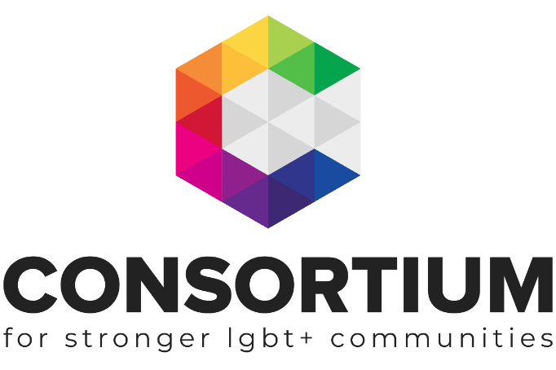
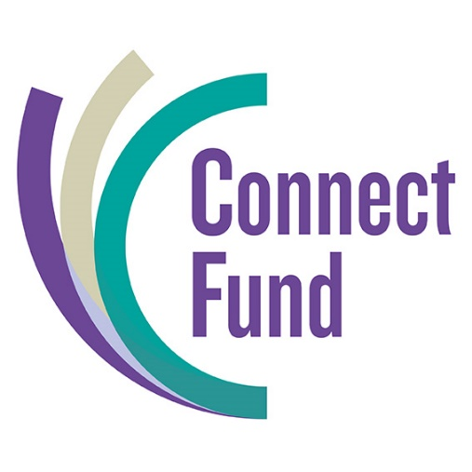

Outcomes
Toolkit

This Toolkit is not intended to be a definitive guide.
It is designed for LGBT+ groups to gain a better understanding of the subject matter.
All the information provided was up to date at the time of creation.
This toolkit was created by Consortium in 2021.

As you work through the factsheet topics you will see a range of icons which are designed to alert you to additional information and support at the appropriate time.
Group Activity: Get your volunteers, colleagues, beneficiaries or Trustees involved in this part of the toolkit

Additional Resources Available: Click on the icon to find more information on the topic

Webinar Available. Click on the icon to take you to a recorded webinar on the topic

Additional Support Available: Email us if you need more support or information

Important Information: Don’t be tempted to skip a section with this icon next to it

External Link or Resource: Clicking on this icon or a link by it will take you to an external resource or webpage

This toolkit has been produced thanks to a grant from the Connect Fund.
The Connect Fund has been set up to strengthen the social investment market in England to better meet the needs of charities and social enterprises. Known as the ‘Social Investment Infrastructure Fund’, it is a £6 million fund for grants and investments that Barrow Cadbury Trust manages in partnership with Access – the Foundation for Social Investment.
www.connectfund.org.uk

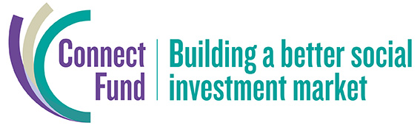

Barrow Cadbury charity number 1115476
Contents
- Introduction
- Terminology
  - What is an Aim
  - What is an Activity
  - Want is an Output
  - What is an Outcome
  - What is the Impact
- Measuring Outcomes
- Outcomes Framework
- Theory of Change
- Outcomes as an Income Generator

Introduction

The term outcome is used regularly in the voluntary and charity sector, but there is often confusion as to what this actually means. What is an outcome? How is an outcome different from an output? And how is an output different from an activity? And what on earth is an aim? Aren’t they all just different words for the same thing?
These are very common questions which many groups find confusing. This introductory toolkit will help your group understand the terminology and then start the process of identifying your organisation’s outcomes and how best to measure them.
In collaboration with LGBT+ groups, Consortium has developed a comprehensive Outcomes Framework, which is the next step once you have worked through this toolkit to get to grips with the basics.
Through the development of this toolkit, and the link through to the LGBT+ Outcomes Framework, we hope LGBT+ organisations will be well positioned to set out their strong case for support, no matter what area of LGBT+ work they undertake.
As organisations continue to explore income diversification and seek a range of income sources (e.g. grants, corporate funding, social investment, enterprise development, individual giving), articulating the impact your organisation has through the use of outcomes based thinking will become increasingly important.
To help with the complexity and challenges outcomes thinking can present organisations, we have provided links through to detailed case studies of organisations who are at different stages of their outcomes thinking and sharing their experiences.
As always, if your organisation has questions, or needs additional support, get in touch with the Engagement Team by contacting admin@consortium.lgbt

Terminology
Language around outcomes can be a little perplexing but we are here to help! We have deliberately started this toolkit off with some important definitions. Do take the time to digest each of them as this grounding will enable your organisation to adopt outcomes-based thinking much quicker. Confusion across these terms is common so don’t worry if it takes a while to get them right. Just keep coming back to this page, or keep a print out of this diagram.
Also, when it comes to getting to grips with this, don’t view everything as a linear process. Feel free to start with an area that makes more sense to you and your organisation as an easier entry point. Regardless of where you start on this journey, keep in mind it can be helpful to move backwards and forwards on the terms to examine the links, differences and revise as necessary.
Please also note that different funders / organisations may use slightly different language which we recognise adds to the confusion. So, when working through this toolkit, consider the definitions more than the individual word itself. Remember, we are always here to help so do reach out!
Aims are what you set out to change (or the purpose of the work)…
The aims you write should be broad intentions of what the organisation wants to achieve by undertaking their work. Aims aren’t necessarily measurable. Aims will often begin with the word “to”. For example:

- To support LGBT+ organisations to better understand what outcomes are
- To provide practical tools for LGBT+ organisations to create a theory of change

Activities practical things you DO to make a difference
The practical work you will need to do to make your project happen or to ultimately bring about the change you want to see. In terms of language, they are all verbs (an action). Some examples of this could be (not exhaustive!):
- Holding meetings
- Recruiting participants
- Writing resources
- Designing training
- Creating a campaign

Outputs the quantity of things that happen as a result of your activities
Directly linked to your activities, these are putting numbers against those activities. Some examples could be:

- 25 people attended meetings
- 5 resources published
- 9 participants recruited
Remember: Outputs measure numbers of things, they are countable—they don’t address change or value (this comes next).
Outcomes are the changes that happen as a result of your work or project. These are the changes that your organisation can achieve and might be short term, medium term or longer term.
These can be changes in individuals' lives, whole communities, systems or sectors or policies.
Outcomes may reflect:
- Shorter term: a shift in knowledge, raised awareness, increased capabilities,
- Mediium term: changes in attitudes or behaviours, increased safety or wellbeing
- Longer term: broader results such as reduction in phobia experienced.
For example:

- Older LGBT+ people feel less isolated
- Trans people feel more confident in influencing law reform
- Hate Crime incidents are reduced
- LGBT+ people have improved sexual health

Change is the key word here and we will take a look at this in more detail below

Let’s take a look at these four elements in a project-based example:

Project Description: We are an LGBT+ group who are applying for a grant to tackle Homophobic, Biphobia and Transphobic Bullying in schools across Devon.

Aim / Purpose: To ensure that schools in Devon are safe spaces for young LGBT+ people

Activity:
- Creating a training package and template reporting system
- Deliver training sessions to senior management teams at participating secondary schools in Devon

Output:
- 150 teachers receive training on tackling HBT Bullying
- 20 schools receive support on embedding reporting systems

Outcomes:
- Teachers report an increase in their confidence in recognising and addressing HBT Bullying
- Increase in reporting of bullying incidents

Impact:
- LGBT+ young people are able to ‘come out’ without any fear of discrimination
- The school environment is phobic free

Impact is the ‘bigger picture’. Focus is on longer term change you want to see as a result of your work or project and cannot be achieved by your organisation alone.
This is likely to go beyond any specific time period spent working on a project (which are more likely to be your outcomes).
They will be things that will take much longer than a project period to achieve—think of them like the ‘golden ticket’ or aspiration, like the example above.

Differentiating between Outputs and Outcomes

Often the most confusion is differentiating between outputs and outcomes and it can be helpful to apply the “so what” test to check that you are correctly expressing outputs and outcomes.
At a quick glance many outputs sound like ‘the end result’ of a project so it can be helpful to read the statement out loud and ask ‘so what?’ to determine if change has occurred to check if you are expressing an output or an outcome…
25 Young people gain a Duke of Edinburgh Award.

The word gain has been used so it sounds promising…could this be an outcome?

25 Young people will gain a Duke of Edinburgh…so what?

Now we’ve asked ‘so what’ it’s clear that change has not been described so it is an output

The change in this instance may be…leading to ‘increased confidence’, ‘improved team skills’…etc

Take your time to review the information above and then have a go at this activity to ensure you have got to grips with the differences.

ACTIVITY
Review the information below and copy each statement next to the category where you think it belongs in the table provided:
Example One:
25 Bi women attend 2 events
Bi women report that they feel more represented in service design
To ensure bisexual women have equal access to service provision
Staff develop a plan to run a series of events to consult bisexual women on how they use their service and what they can do different
Bi women have access to support and report an increase in positive mental health

Example One - Your Answers
Aims
Activities
Outputs
Outcomes

Example Two:
50 LGBT+ older people consulted
To ensure LGBT+ older people have access to safe, social opportunities for positive wellbeing
Older people report feeling more connected and part of the community
Design a consultation to gain an understanding of what activities older LGBT+ would like
Staff to develop a programme of activities based on consultation
Older people report in increase in wellbeing
12 one-hour social club sessions deliver with average 10 attendees

Example Two - Your Answers
Aims
Activities
Outputs
Outcomes

ANSWERS: The correct categorisations can be accessed using this link
Measuring outcomes

Now that you have gained a clearer picture of what an outcome is and associated terminology, we will take a look at how to ‘measure’ your outcomes in order to demonstrate that change has taken place.
This is essential for your organisation to be able to evaluate the effectiveness of your work which can in turn help inform new or revised projects and it will inform grant applications to help your group gain funding.
It’s not enough to say ‘LGBT+ older people will report an increase in confidence’, as funders will want to know how you are measuring an increase in confidence and also what ‘success’ looks like.
For example, do you expect ALL project participants to report an increase in confidence or a percentage of them? Does your measure include specific figures that can be reported, such as an increase of 2 points or more on our 10-point confidence scale? At what point is the measure used (does it require a before and after assessment, is it a reflective tool used at the ‘end’ of a project etc).
This approach is sometimes referred to as SMART outcomes. This offers a great opportunity to cross-check your outcome against some clear criteria:
- Specific – Answers the ‘what is to be done’ and ‘how will you know it is done’ questions
- Measurable – Could be numerical (e.g. % improvement) or other measurable form (e.g. something prevented as result of the work)
- Achievable – Can you really achieve this in the timescale specified? They need to be within your capabilities
- Realistic – Is it relevant and proportionate?
- Time bound – Being clear on what timeframe you are working to
The above example may be presented as:
By the end of 12 months, 80% of LGBT+ older people participating in our social club will report an increase of at least 2 points on our 10-point confidence scale, administered at the start of the project and at the end.

A few things to think about…
Measuring outcomes:
- If you’re conducting surveys, think about when e.g. before and after to demonstrate a change.
- Yes, you can use observations and yes, they will be subjective, but they add human stories to data. Just be clear /transparent when you are talking about observations.
- Online tools. There is a huge variety of online tools available to measure progress for service/support users. From free platforms for expensive bespoke systems – we explore outcome measurement in our LGBT+ Common Outcomes Framework Guide (see below for further information about the Outcomes Framework).
- Narratives and testimonials

Validated measurement tools:
It can add weight to project proposals to include at least one ‘validated’ measurement tool. This refers to a measure that is recognised within its field. They are also used with a broad range of clients and can be helpful to provide comparative data.

As an example, if two organisations applied to the same funder with project proposals focused on improving mental health and wellbeing – all other factors being equal, a funder is more likely to support the project using a recognised and validated outcome tool. Take a look at the examples below to get an insight into how funders view projects:

Project one: we will measure wellbeing using the validated Warwick-Edinburgh Mental Wellbeing Scale…

Project two: we will measure wellbeing by asking our members how they feel…

The LGBT+ Common Outcomes Framework provides an overview of some measurement tools your organisation might want to consider.

LGBT+ Common Outcomes Framework Guide
To help groups better understand and define their outcomes and to provide a range of tools to measure and demonstrate change, Consortium has collaborated with members to develop the LGBT+ Common Outcomes Framework.
The framework details five key domains. We believe groups should be able to see the work they undertake reflected in one or more of the domains.

Five Outcome Framework Domains:
- Improved Wellbeing
- Social Connectedness
- Safe, equal communities
- Improved service provision
- Improved policymaking

As you can see, these are broad domains that encompass the range of work that takes place in our LGBT+ sector. Each domain is then further subdivided, for example ‘Improved Wellbeing’ incorporates the following three sub-categories;
- personal wellbeing
- emotional wellbeing
- physical wellbeing

A wide range of very different projects and services that may not feel in any way connected can be described by the Improved Wellbeing Outcome. For example: youth groups, 1:1 mental health support, older peoples social club, sports groups, arts and craft projects, etc.

LGBT+ Common Outcomes Framework
Domain | Sub-categories
Improved Wellbeing | - Improved personal wellbeing  - Improved emotional wellbeing  - Improved physical wellbeing
Social Connectedness | - Facilitating and building capacity for communication among LGBT+ people  - Increased discussion and understanding about LGBT+ lives  - Foster diversity in local and public life
Safe, equal communities | - Individuals feel safe and supported to be open about themselves  - Improved visibility of LGBT+ issues  - Reduced societal homophobia/ transphobia / biphobia and reduction of  harm resulting from it  - Greater compassion and fostering of diversity within LGBT+ communities  including intersectionality and socio-economic differences
Improved service provision | - Increased amount of mainstream support available  - Services are confident in welcoming LGBT+ people and vice versa  - Meaningful person-centred approaches in all services and settings  - Improved perceptions of mainstream and specialist services
Improved policy making | - Robust evidence of need, including social and economic impact of  prejudice  - Professional Bodies and Policy Makers have increased understanding of LGBT+ issues  - Increased LGBT+ influence and ownership
For more information on how Consortium Members have embedded the LGBT+ Outcomes Framework please click the links below to take a look at three case studies:
- Mind Out
- Leicester LGBT Centre
- Opening Doors

ACTIVITY

Think about a specific project or service that you currently deliver or would like to deliver. Using the information you have learnt through this toolkit, have a go at presenting the project information below. And please do get in touch with the engagement team if you’d like additional support.

Some funders allow flexibility when setting your outcomes and others specify that you must have at least three, so it’s a useful number to keep in mind. Avoid over complicating matters for yourself and, where possible, provide one clear measure per outcome.

“I once set 5 different measurement methods for each of our 3 project outcomes and several were complex and time consuming to achieve…such as an ‘observational behaviour summary gathered from teaching staff and family’. The funder was obviously impressed as we got the grant, but when it came to project evaluation, I realised how complicated I made it. Now I stick to one measure per outcome!” Consortium member

Aims
Activities
Outputs
Outcomes
Measurement tools and description of success
You may wish to watch this brief webinar that summarises what we’ve covered in this toolkit so far.
Theory of Change
You may have heard the phase ‘Theory of Change’ and wondered what is this?!
Theory of Change is a method used for planning for social change. It starts by making you define your goals first, then requires you to works backwards to identify what you will be required to do to achieve those goals. If you’ve completed the activity above to set out your Aims, Activities, Outputs, Outcomes and Outcome measures…then you are well on your way to producing a Theory of Change!
It’s a great visual representation of your work and can be used to describe an individual project or you can complete one for your whole organisation. Presenting your work in this way can be extremely useful to inform your strategic planning and inform funders. It can also be helpful for the general public to better understand the work of your organisation.
Once you have worked through this toolkit, and have a better understanding across this area, you might want to consider developing your own Theory of Change. Guidance around using a Theory of Change including a completed example can be found here.
A Template Theory of Change which includes a breakdown of the different areas e.g. outcomes and outputs can be found here.
Outcomes as an income generation tool
Outcomes not only help your organisation to think about planning out a project or specific piece of work, they can also be useful tools in terms of broader income generation. Consider setting some organisation wide outcomes, perhaps framed through a Theory of Change as outlined above, that can serve as a way of articulating the difference your organisation will make to the lives of those you work with.
As you explore diverse income sources, for example corporate donations or as you venture into social investment or enterprise development, putting forward a strong case for support will be important. Clearly articulating the difference you will make to people’s lives, and how you will achieve this, will help those looking to invest in your organisation understand the plans you have and the role they could play in supporting you. Please use this link for further information on different income generation methods.
Consider integrating your outcomes or Theory of Change into your strategic plan.
We hope you have found this toolkit useful.
Now that you have worked your way through, it is recommended that you review the LGBT+ Common Outcomes Framework.
If the LGBT+ sector takes a more common approach to speaking about the work it does, and the difference it makes, we can amplify each other’s work and build on the evidence and data to secure future funding for all organisations.
For more information on how Consortium Members have embedded the LGBT+ Outcomes Framework, please click the links below to take a look at three case studies:
- Mind Out
- Leicester LGBT Centre
- Opening Doors

