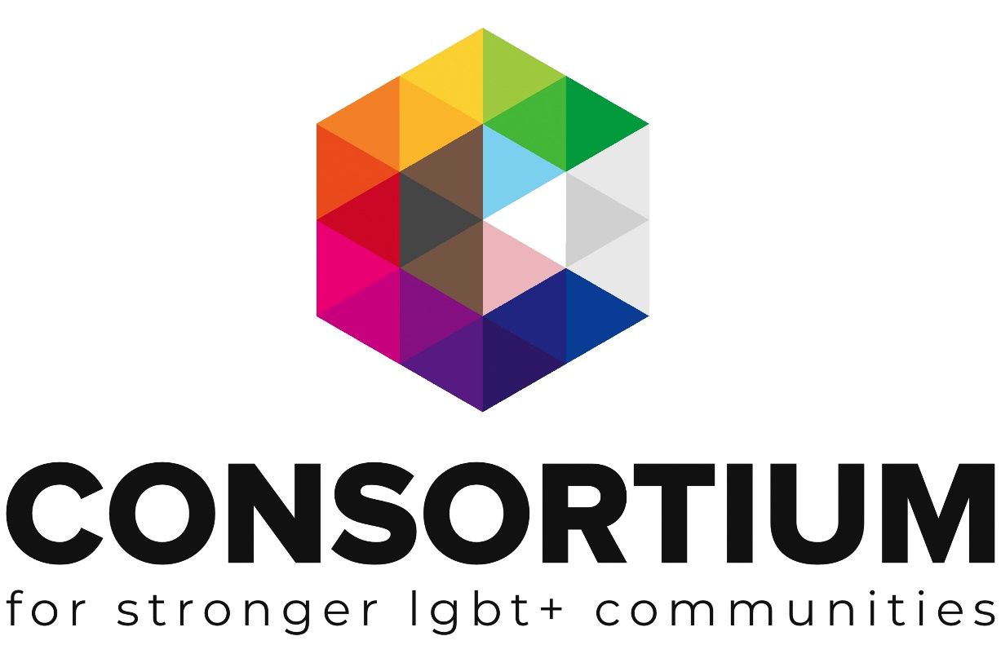
LGBT+ Community Groups Start Up
TOOLKIT

These online toolkits are designed for LGBT+ Groups and organisations to work through with key volunteers, staff or Trustees to develop key policies, procedures, plans and management techniques.

As you work through the toolkit you will see a range of icons which are designed to alert you to additional information and support at the appropriate time.
Group Activity: Get your volunteers, colleagues or Trustees involved in this part

Additional Resources Available: Click on the icon to find more information on the topic

External Link or Resource: clicking on this icon or a link by it will take you to an external resource or webpage
Important Information: don’t be tempted to skip a section with this icon next to it.
Webinar Available. Click on the icon to take you to a recorded webinar on the topic

Additional Support Available: Email us if you need more support or information

This Toolkit is not intended to be a definitive guide or template.
It is designed for LGBT+ groups to work through a series of activities and information in order to build a better understanding of the subject matter.
All the information provided was up to date at the time of creation.
This Toolkit was created by Consortium 2020.

Contents

Launching a new community group

- Support
- Purpose
- Structure
- Finances
- Funding
- Promotions
- Volunteers
- Public meetings
- Policies
- Health & Safety
- Insurance
- Safeguarding

Launching a new community group?

Whether you are planning to launch a brand-new community group, or resurrect a group that is no longer operating, there are a number of key factors to consider, to help things go smoothly.

Remember you are not alone!

To support you in these initial stages why not become a Consortium Member. Its free to join for low/no income groups and you will gain access to an extensive range of resources, training, access to our Funder database, discounted insurance and 1:1 support. We also have a number of established networks for groups with a shared focus. Please do get in touch to find out about joining.
Below are some key start-up questions to consider and links to relevant support documents. There is no ‘fixed way’ to go about setting up a community group - if a section does not feel relevant to your situation, just move on to the next topic.
Though do keep in mind, any sections marked with the ‘important icon’
should be considered by all.

Support

Is there a group of individuals interested in setting up the community group with you or are you currently looking at this on your own?

Don’t worry if you are exploring this on your own – we’re here to help, so please do get in touch with Consortium.

Think about any network contacts you have of people you could invite to explore it with you? Note down your potential colleagues and support network contacts and it can also be useful to include their relevant key skills and areas of specialism.

Purpose
What is the key purpose of your community group?

If you haven’t already set your organisation’s mission and vision, then this can be a useful starting point.

Your mission defines your organisation's objectives and its approach to reach them: e.g. To deliver LGBT inclusive practice training to health care professionals working in Devon.
The vision describes the desired future position of the organisation:
e.g. To ensure that every LGBT person living and working in Devon feels safe and has judgment-free access to healthcare.

Both the mission and vision can be summed up in statements that you can use to communicate what you do and where you are headed as an organisation.

Use this space to draft a mission statement and vision statement

Below is a list of some of the key functions and areas of work a community group may focus on, together with a list of target service users for those seeking to reach a particular group of people within the LGBT+ community.
Tick all those that you feel may be relevant to your proposed community group and add any others that are not listed:

Key areas of work | Service users | Key Function
Advice/Information | LGBT+ People | Arts
Advocacy | Bisexual Men | Campaigning
Befriending/1:1 | Bisexual Women | Community Development
Counselling | BME/People of Colour | Health & Wellbeing
Disability | Gay Men | Interest/Social Group
Domestic Abuse | Lesbians/Gay Women | Pride Organisation
Drop-in Service | Men | Research
Education/ Employment & Training | Non-UK Residents | Sport
Equal Opportunities / Discrimination | People of Faith | Youth Group
Events | People over 50 | Other
Faith | People with disabilities
Healthcare | Trans People / People with gender histories
Helpline | Women
Housing / Homelessness | Young People
Immigration | Other
Mental Health

Outdoors/Sports

Self-help / Support Group

Sexual Health

Social Group

Substance Misuse

Volunteering

Other

Note down any additional thoughts you and your colleagues have with regards to the purpose of your group. For example, is your idea in response to an identified need, personal experience, shared hobby… do you plan to host physical meetings, or will it be an ‘online community’ etc?

Structure
To help your community group take shape it is useful at this stage to explore which organisation structure you think will suit your group best. Most small groups start out as unincorporated groups and then as they expand become more formalised to keep in line with current regulations on income and so on.

Unincorporated Groups are the simplest type of organisation. They are cheap and simple to set up, but please note, Trustees take on personal liability and shared responsibility for the group’s actions.

For more information to help you explore your options, take a look at these resources:

Guidance Tool Legal Structures

Choosing a legal structure factsheet

Registering a charity
Discuss with your colleagues and note down your thoughts with regards to the most appropriate structure for your needs and any actions you need to take put the structure in place such as developing a constitution.

If you are unsure on which structure to opt for, or would like help developing your constitution / incorporating your group etc, please contact Consortium’s engagement team for support.

As part of this process you will also need to consider what your community group will be called. If you are resurrecting an existing group, you may decide it’s a good time to change the name.

Keep in mind if an existing group is incorporated and you choose to change the company name this will require a legal change and impacts on the constitution, bank accounts, Companies House, and so on.

It may therefore be preferable to maintain the ‘legal name’ but focus your logo and brand with the new wording.

For example: legal name LGBT Worcester Community Group
Logo and brand ‘working name’: Worcester Rainbow

If the group has charity status you will need to inform the Charities Commission of your working name (even if there is no change to your legal name).

Discuss with your colleagues and jot down ideas for the group name. Take a look at existing LGBT+ community groups to get ideas. You may decide to take a vote to choose a winner! For further information around branding, please request our factsheet.

Basic Finances

This may not be a concern in your early stages, but it can be useful to think about setting up a bank account or partnering with a larger organisation and utilising their facilities.
Take a look at our factsheet on holding money and bank accounts.

If you are planning to open an account, note down who will be your signatories (best practice advises 3 signatories registered to the account).

If you are seeking to hold funds with a partnership organisation – make a note of those that you may be able to approach (for example an established local LGBT+ organisation in your local area).

In line with the factsheet do NOT hold money in your own a/c for your group

Funding

In the early stages you may not require significant funding. Depending on the nature of your proposed group and your network contacts, you may be able to secure a venue at no cost and online promotions (see below) are mostly free, so it may simply be a matter of providing basic refreshments (teas/coffees/biscuits) for initial group sessions/meetings. Consider approaching local supermarkets as they may be willing to donate products or provide a gift voucher to cover refreshment costs.

You can also explore fundraising options to generate a small float. Take a look at our ‘Fast Fundraising Ideas’ factsheet for inspiration.

Consortium members can access our Funder Finder: a directory of funders that we know are supportive of LGBT+ groups and organisations.
Please do get in touch to find out about joining.

If you know you will require funding beyond a small float due to the nature of your group, we have a number of additional resources to support groups with fundraising including writing grant applications.

Fundraising Factsheets:

Types of Fundraising - a brief overview of seven key fundraising options

Building a case for support

Fundraising Webinars (short subject tasters)

Developing corporate relationships

Fundraising from Grant Makers

Funding Core Costs

Toolkits

For groups keen to explore this is more depth we have two focused toolkits which can be ordered:

Developing a fundraising plan

Fundraising through grant makers (bid writing)

Promotions

In order to reach the local LGBT+ community in your area it is important to think about the different ways you can get information out about your new group. Liaise with your colleagues and support network that you identified in the activity above, especially if individuals have any promotional or marketing experience.
It is best practice to avoid using your own personal phone number and social media accounts when reaching out to community members. If it is not viable to fund a separate phone, consider email as the main means of contact on your promotional materials.

Have a look at the list below and tick all of the promotional options that you feel are accessible to you / options that you’d like to pursue. Keep in mind some of the options may require a small amount of funding, for example to print flyers.

Promotional options

Facebook page
Twitter
Instagram
Website
Leaflets (e.g. to display in your local library / supermarket notice boards etc)
Local newspaper advert
Mailing list (if resurrecting an existing group)
Via relevant organisations (e.g. a blog / post on another organisation’s website, social media etc)
Other promotional ideas
For further information about getting the most out of social media, please access our resources:

Implementing a social media plan

Facebook essentials

Getting the most out of twitter

Volunteers

Many new community groups are run entirely by volunteers, especially in the early stages as it can take time to achieve funding for paid staff (and indeed many community groups do not want to become ‘employers’). It is therefore important to ensure you have effective systems in place to make the most out of your volunteers.

For very small groups their approach can often be extremely informal, such as a ‘friend who has offered to create a basic Wordpress website’…and whilst these sorts of offers are great and help to get things moving, it is important to have a basic volunteer policy in place to avoid potential issues.

In the above example, it can become problematic (particularly where personal friendships are involved) if tasks take longer than you had expected, or don’t meet the groups needs or don’t happen at all!

To avoid such complications, take a look at our brief webinar and request our volunteer toolkit on developing a volunteer programme. These resources cover the initial planning stages of taking on volunteers, recruitment, induction, and retention.

Make a note here of any actions required to ensure you are ‘volunteer ready’. Such as working through the Volunteer toolkit or developing a basic policy document. You may also want to record details of anyone already volunteering their time with your group.

Public meetings

It is likely that you will be bringing people together in a public setting. When arranging to deliver your community group services, there are a number of factors to consider:

- Ensure the venue you choose is LGBT+ inclusive.

- Consider accessibility needs.

- Consider required facilities relevant to your group’s needs (e.g. changing facilities for a sports group, play facilities for a parent and toddler group and so on).

- Avoid venues serving alcohol.

- Ensure the venue you choose is well connected by public transport.

- Ideally select a venue that will be staffed during your group’s meeting times (this helps minimise health and safety risks and avoids issues such as needing keys to access and lock up).

- Consider the timing of your group for maximum reach: early evenings can be effective or weekend day times.

- Consider ways to ensure your group is welcoming to a diverse membership: for example, late evening meetings may put off older people, does the venue have gender neutral toilets etc and as mentioned above avoid venues with alcohol to include different faith groups.

- Consider available funds and ideally seek venues offered at no cost.
Public libraries are often a very good starting point for initial meetings to address many of the above criteria.

You may also consider getting in touch with your Local Authority and / or CCG for potential venues. Depending on the nature of your community group, you may wish to approach organisations with a shared interest, such as a local sports club.
Note down any suitable venues you wish to approach and contact info if known.

Basic policies

There are some key policies that you really should have for your LGBT+ Group covering topics such as safeguarding, equality and diversity and data protection.
These policies should be in place to protect both those running the group, and those using the support, services or events offered by the events.
Below is a list of some of the essential policies all groups should have, and then a list of policies that it would be good practice to have (if relevant).

Have a look at the list below and tick all of the policies relevant to your group that you need to put in place:

Essentials

Health and Safety
Equality and Diversity
Data protection and confidentiality
Complaints
Volunteer policy
Safeguarding policy

Others

Financial management
Bullying and Harassment
Conflicts of Interest
Reimbursing Expenses and Purchases
Whistle Blowing
HR policies relating to paid staff

Please contact Consortium if you would like 1:1 support to develop your initial policy documents and don’t forget that members can access our resource library which includes a number of useful templates.

Health & Safety

It is important to think through some basic health and safety factors to ensure the wellbeing of individuals, your team and other group attendees. With any public gathering and particularly voluntary sector groups, vulnerable individuals may attend including those with mental health issues.

There is also the risk that hate groups or HBT-phobic individuals may attempt to gain access to your group in order to cause disruption and distress.
Remember you are not alone – please do contact Consortium for support. You may be able to invite along contacts from an established LGBT+ community group in your area for support when you first launch.

If you are able to secure a venue that is staffed during your group, as outlined above this will help minimise health and safety risk factors.

Other ways to reduce potential risk include:

- Ensure you have been given relevant fire procedure information from the venue you are using.

- Ensure you have a least two forum team members present before you welcome in guests.

- Have a sign-in sheet to record who is attending.

- You may wish to withhold the venue address from public promotions and request people get in contact for the information – however this may act as a barrier to attendance.

- Consider your colleagues – and if possible, ensure at least one person is present who has experience in managing difficult situations (such as those in frontline public sector roles).

- If you are providing any refreshments, ensure items are labelled or original packing is available for those with allergies.

- Ensure you have access to a phone in case you need to make an emergency call.

Insurance

Government guidelines state: There is no law that states you must buy insurance for a voluntary or community event – but you might want to make sure you are covered in case something goes wrong and someone makes a claim against you. If you are renting or using someone else’s building, you may be covered by their insurance, do check to see if this is the case.

Consortium members can access discounted insurance, so do visit our website to find out about joining.

Safeguarding

For any group connecting with members of the public, it is important to have a basic understanding of safeguarding.

Your systems should be proportionate to the services you plan to provide, and the client groups involved. For example, a group providing a monthly social club for mainstream adults would not require the same level of policy and procedure as a group providing 1:1 support to vulnerable teenagers.

Your local Safeguarding Board coordinates all local work to safeguard and promote the welfare of children and vulnerable adults and also provides training (usually free) to any individuals who work with children and / or vulnerable adults. The Board are also there to advise and do keep in mind that at any point if your group has a safeguarding concern, a query or even if you are clear on what to do but you just want reassurance – you can contact them!

A simple internet search of ‘safeguarding board (your area)' will take you to the relevant website.

Note down the web address and any key contact phone numbers listed so you have these recorded.

Also liaise with your colleagues and support network and note down if you have any colleagues with safeguarding training such as those in frontline public sector roles who may be willing to act as a ‘Safeguarding Lead’.

Consortium has produced a comprehensive toolkit to support groups to develop a safeguarding policy and those wishing to review/audit their existing policy. Click here to request the toolkit.

For further information about running community events please access this comprehensive government guide.

Now that you have worked through this introductory workbook you may wish to transfer your activity responses onto a community group start-up template so that you have all the relevant information in one simple reference document.
Access the template here.

