Top Tips to launch a new LGBT+ community group

For detailed information to support you with the areas detailed below and much more – please request our Community Group Start-up Toolkit via the members dashboard

Get connected!

Speak to your network contacts and establish who may be interested in developing the community group with you.

Become a Consortium member (free to low/no income groups) to again access to a comprehensive package of support. Join Us

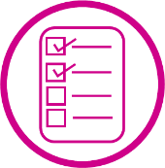
Get organised!

Consider the remit and role of your community group to develop your initial aims/goals.

Research the different organisational structures and find the one that best suits your needs.

Open a group bank account ideally with 3 signatories / or approach relevant established organisations who may be willing to hold funds for your group

Get out there!

Explore accessible venue options – public spaces such as libraries are a good starting point

Promote your new community via social media, through your network contacts and if funding permits with hard copy flyers

Invite them….and they will come!

