LGBTQ+ Community Outreach Youth Support Worker

Fixed Term; until 31st October 2023 to be extended subject to funding

Dear Applicant,

Thank you for expressing an interest in this role*. You will join a dedicated, professional and passionate team supporting LGBTQ+ young people, young adults and their families in Somerset. We are looking to recruit an LGBTQ+ Community Outreach Youth Support Worker who can deliver a range of services across the county, by raising awareness, providing advice and guidance, challenging discrimination and providing support for LGBTQ+ young people in Somerset.
With the support of The National Lottery Community Fund, we are delighted to be in a position to appoint two dedicated LGBTQ+ Community Outreach Youth Workers and the successful applicant will be invited to help creatively shape this service.
Deadline for submissions is Friday 3rd December 2021 6pm.
Interview date and location: Monday 13th December between 4.30-8.30pm, Taunton.
For an informal conversation about these exciting new roles, or if you have any questions about the recruitment process, accessibility, or if you need this form in a different format, or in hard copy, please call Lisa Snowdon-Carr on 07799 136552 or email Lisa@2bu-somerset.co.uk.
This position requires you to complete an enhanced DBS check and provide references.
We look forward to hearing from you and wish you luck with your application.
Best wishes,

Lisa Snowdon-Carr (she/they)
Chief Executive

* These roles are deemed to be a genuine occupational requirement under Schedule 9, Paragraph 1 of the Equality Act 2010 for protected characteristics, in this case, to be a Lesbian, Gay, Bisexual, Trans (LGBT+) worker who will reflect the membership criteria of the target group

About 2BU Somerset

Established in 2003, 2BU-Somerset provides a specialist support service serving the needs of young lesbian, gay, bisexual, transgender and questioning (LGBTQ+) people across Somerset.

Our central aim is to help build resilience, confidence and bring each young LGBTQ+ person to a place of healthy self-acceptance. We provide a safe environment for LGBTQ+ young people to come together and gain support from both staff and peers. We offer regular support groups which provide a varied holistic and tailored programme to meet the needs of the LGBTQ+ young people. Our activities take place throughout the county of Somerset, offering outreach support when young people are unable to access the central support group.
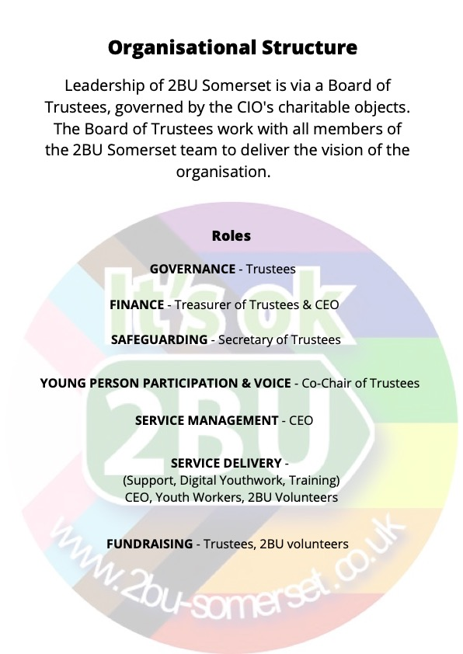

2BU’s Charitable Objects:

- Personal and Social Education: To advance the education of lesbian, gay, bisexual, and transgender and questioning (LGBTQ+) young people to ensure the development of individual capabilities, competences, skills and understanding.

- Equality of Opportunity: To advance human rights and promote equality and diversity and the elimination of discrimination on the grounds of sexual orientation and gender identity.

- Participation and Empowerment: To empower lesbian, gay, bisexual, and transgender and questioning (LGBTQ+) young people through skills development and effective involvement in decision-making, so they might participate more fully in society.

The recruitment process:

We expect to invite shortlisted candidates for an interview in Taunton on Monday 13th December between 4.30-8.30pm. If this is not possible, due to Covid-19 restrictions, we will transfer this to a Zoom interview. If selected for interview, we will also ask you to make a short presentation (5 mins) on the day in which we would like you to address the statement:

Why I want to work with LGBTQ+ young people and for 2BU Somerset.

On the day, the interview process will be in two stages:
- Stage 1 – A formal interview with the 2BU Team.
- Stage 2 – An interview organised by young people attending 2BU which includes your short 5-minute presentation.

We are aiming for a January 2022 start date (dependent on availability and notice period).

Please return completed forms as a pdf email attachment to: Info@2bu-somerset.co.uk with LGBTQ+ Community Outreach Youth Support Worker in the subject line.

Or by post marked as Private and Confidential to: Recruitment, 2BU Somerset, c/o 16 Canal View, Taunton, TA2 8BF. Please ensure your application arrives before the closing-date.

Job Description and Person Specification

Job Title: | LGBTQ+ Community Outreach Youth Support Worker.
Term: | Fixed until 31st October 2023. (Subject to funding thereafter). There is a probation period of 6 months.
Salary: | £19,500 – £21,439 per annum, plus NEST pension contribution
JNC Scale: | SCP range 5-9, based on qualifications and experience.
Accountable to: | Chief Executive.
Hours of Work: | 37.5 hours a week, part time hours are also available.
Location: | Home based, with the ability to travel to a wide range of locations across Somerset as necessary.
Annual Leave: | 28 days, plus bank holidays.  Our leave year runs from 1st April until 31st March.

This diverse and challenging role requires someone who is passionate about youth work in LGBTQ+ communities. You will identify and meet the needs of LGBTQ+ young people to deliver a programme of youth work activities, raising awareness and providing dedicated support in schools, colleges and community settings across the county.
2BU offer a supportive environment, training, regular supervision and appraisal.
Main Duties and Responsibilities
- To work closely as part of a team with 2BU Somerset, young people, volunteers, partners, agencies, parents and carers, amongst others.
- Plan for and deliver sessions, both in-person and online to engage LGBTQ+ young people in a range of settings across Somerset (including in groups, one to one, projects, events and raising awareness).
- Develop positive relationships amongst schools, colleges, voluntary organisations and other youth settings promoting equality and diversity.
- Liaising with and supporting the 2BU training team wherever needed

- Report writing, diary management, use of word/excel to generate records and enable evaluation of 2BU’s service provision.
- Work within the key aims of 2BU Somerset’s charitable objects.
- Attend (and facilitate when required) briefing and debriefing of sessions, including reflective practice and evaluation of the service provision.
- Attend regular supervision meetings according to the role.
- To build and maintain a working knowledge of our own and other organisation’s services in order to refer clients, where appropriate to the best information, advice or support. As well as knowing how to and where to refer young people and families, for more in-depth information, advice and extra support.
- Raise the profile and awareness of LGBTQ+ work in Somerset by linking into local networks and forums.
- Promote and raise awareness of 2BU through social media platforms, attending events and distributing resources.
- Strive to achieve exceptional support for LGBTQ+ young people, promote participation and provide platform for young LGBTQ+ voices to be heard.
- Commitment to adhere to 2BU Somerset’s policies including; Safeguarding, Confidentiality, Equality and Health and Safety Policies.
- Attend all relevant training, staff development and personal professional development programmes.
- Commitment to ensuring and maintaining sensitive and confidential recording and handling of information is strictly in accordance with 2BU Somerset GDPR Privacy policy.
- Keep up-to-date with legislation, issues and best practice developments within the LGBTQ+ community, LGBTQ+ young people specifically and families/carers.
- Commitment to the success, growth, values and ethos of 2BU. To ensure a positive and active profile as a 2BU representative.
- All staff may be asked to undertake other duties and responsibilities where appropriate, as determined by the 2BU Management Team.

PERSON SPECIFICATION

Post: LGBTQ+ Community Outreach Youth Support Worker.

 | Essential | Desirable | Method of Assessment
Qualifications | Willingness and ability to undertake Youth Work training at level 3 | Youth Work Level 3 qualification | I / Q
Proven Ability | Experience with facilitating groups of young people. |  | A/I
 | Experience in working with vulnerable young people. |  | A/I
Knowledge & Skills | Awareness of current legislation and safeguarding relating to young people. | Previous safeguarding training | A/I
 | Good verbal and written communication skills. |  | A
 | Knowledge and understanding of intersectionality and diversity within the LGBTQ+ community. | Previous experience working within the LGBT+ community | A/I
 | Experience of working on your own and as part of a team |  | I
 | Knowledge of how youth and family support and the education sector operate. | Previous experience in the sector | A/I
 | Computer literate with the skills to undertake own administrative tasks, including MS Office and Zoom. |  | A
Special Qualities or Aptitudes | Ability to work sensitively with people who may express challenging views, especially towards the LGBTQ+ community. | Previous direct experience | I
 | Ability to manage and prioritise your workload efficiently |  | I
 | Ability to manage risks effectively, |  | I
 | Ability to liaise between external support services and organisations | Previous direct experience | I
Other Requirements | Willingness to travel across Somerset | Use of own vehicle | A/I
 | Ability to work evenings and weekends (as required) |  | A
 | Satisfactory DBS check |  | Following interview

A – Application form, I – At Interview, Q – proof of qualification.

Application Form
LGBTQ+ Community Outreach Youth Support Worker

Confidential

Name

Pronouns

Address

Email address

Phone number(s)

Education & other Qualifications
Please provide details, in chronological order, of academic/vocational/professional qualifications
.

Previous employment
(Listing most recent first, please tell us the name and address of present/former employer(s), the positions held, dates and a summary of duties).

Tell us how you meet the essential and desirable requirements as listed in the person specification for this role
This is your opportunity to tell us about your experience and why you are suitable for this role.
Please ensure you cover all the areas marked as A in the method of assessment column in the person specification

Is there anything else you want to tell us about yourself and why you want to work with 2BU and LGBTQ+ young people?

References
Please give the name, occupation and contact details of two people who can be approached for references following your interview.

Name:  Occupation:  Address:  Email:  Telephone:  Relationship to you: | Name:  Occupation:  Address:  Email:  Telephone:  Relationship to you:

DECLARATION
Information from this application may be processed for purposes registered by the Employer under the Data Protection Act 2018. Individuals have, on written request, the right of access to personal data held about them.
I give my consent to 2BU Somerset processing the data supplied in this application form for the purpose of recruitment and selection for the role. The information 2BU Somerset will hold includes my contact details, application form, references and my performance in any interview(s), if offered.

I confirm that the information given in this application is true. I understand that if any
false or misleading information is given or relevant information is deliberately withheld, this may result in the application being disqualified or the appointment being terminated.
Signed:

(An electronic signature is acceptable)
Print Name:

Dated:

TERMS AND CONDITIONS OF EMPLOYMENT

1. The post is a 2-year fixed term post with the intention of continuation.
2. The post-holder will be employed by 2BU Somerset.
3. The appointment is subject to Enhanced DBS Disclosure and satisfactory completion of a six-month probationary period.
4. The annual leave entitlement is 28 days (pro rota) to be taken by agreement.
5. The appointment will be terminable on either side by giving one months’ notice.
6. An appropriate travel allowance will be paid for travel incurred whilst on 2BU’s official business, to and from a designated travel base.

Equal Opportunities Monitoring Form

2BU Somerset is committed to the Principle of Equal Opportunities and strives to be an Equal Opportunity Employer. This information will be used solely for monitoring purposes and will be treated as confidential; it will be separated from your application upon receival and before any consideration of candidates takes place.

Completion is entirely voluntary and is not required for consideration for employment.

We have opted to allow an opportunity for self-describing all equality questions, as a true reflection of our commitment to intersectionality, and showing how you are not a box.

Application for the Role of: | LGBTQ+ Community Outreach Youth Support Worker
Age:

How would you describe your gender?

How would you describe your sexuality?

How would you describe your religious belief?

Do you consider yourself to have a disability?

If yes to above, would you like to describe your disability(ies)?

How would you describe your ethnic and/or cultural origin?

