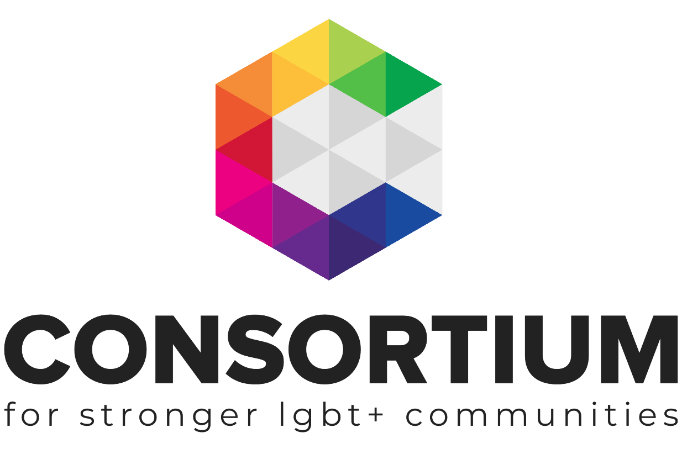
Strategic Planning
For LGBT+ Groups

LGBT+ Futures Programme Workbook

As part of the LGBT+ Futures Fund Programme Consortium and its partners are delivering a range of learning and skills development opportunities.

These online toolkits are designed for LGBT+ Groups and organisations to work through with key volunteers, staff or Trustees to develop key policies, procedures, plans and management techniques.

As you work through the toolkit you will see a range of icons that are designed to alert you to additional information and support at the appropriate time.
Group Activity: Get your volunteers, colleagues or Trustees involved in this part of the module

Additional Resources Available: Click on the icon to take you back to the module page and find more information on the topic you are learning about

Webinar Available. Click on the icon to take you back to the module page to find a recorded webinar on the topic you are learning about

Additional Support Available: Email us if you need more support or information whilst you are working through this module

Important Information: don’t be tempted to skip a section with this icon next to it.

External Link or Resource: clicking on this icon or a link by it will take you to an external resource or webpage

This Toolkit is not intended to be a definitive guide or template. It is designed for LGBT+ groups to work through a series of activities and information to build a better understanding of the subject matter.
All the information provided was up to date at the time of creation.
This Toolkit was created by Consortium for the LGBT+ Futures Fund Skills Development and Training Programme 2019/20.

Contents

Section 1: Introduction to Strategic Planning
- Who Needs a Plan?
- Vision and Mission
- Values

Section 2: The Planning Process
- Internal assessment e.g. SWOT
- External assessment e.g. PESTLE
- Timing
- Exploring funding & sustainability
- Risk appetite
- Consulting Stakeholders
- Setting Goals
- Delivering Goals: Theory of Change
- Measuring and Monitoring

Section 3: Writing the Plan
- Audience
- Format
- Key elements

Section 4: Implementing the Plan
- Milestones
- Reviews

Introduction

The words 'strategy' or strategic' are thrown around in meetings a lot these days and whilst we are all pretty sure that we need to think strategically and have a strategic plan, we might not all be so sure where to start! Going back to basics can be the most strategic place to start:

Strategic: Relating to the identification of long-term or overall aims and interests and the means of achieving them.
Plan: A detailed proposal for doing or achieving something.

In other words, a strategic plan is like a road map for your organisation.
The plan sets out what your aims are and how you intend to achieve those aims, considering how you can maximise your organisation's resources and impact along the way.

To start the strategic planning process, you need a clear understanding of where your organisation is now along with a clear picture of where you are headed.
This toolkit will provide you with the tools and approaches to help you work out your route.

Who needs a plan?
You certainly don’t have to be a large organisation to benefit from developing and writing a strategic plan, you could be a volunteer-led support group with an income of £3,000 and get a lot out of the planning process. As much as anything, reviewing, reflecting and planning offers your organisation the chance to connect with its aims and purpose, its stakeholders and beneficiaries, getting fresh perspectives and making sure you’re on the right track.

A strategic plan can also be a powerful marketing tool as well as an organisational road map, it can be for internal use or can be fancied up and summarised for external communications. It can create an opportunity to show how excited you and your team are about the amazing work you do to.

Never go into it thinking that it will be a document to gather dust on a shelf, it's a living document that needs to be reviewed and developed. You should look at it as something the organisation can use daily to guide key decisions you need to make. It should outline what you exist for, what key goals you want to achieve and a summary of how you want to achieve those goals.

It can be as simple or as complex as you want or need it to be.

Vision and Mission
If you haven’t already set your organisation’s mission and vision, then you will need to do this as a starting point.

Your mission defines your organisation's objectives and its approach to reach them: e.g. To deliver LGBT inclusive practice training to health care professionals working in Devon.
The vision describes the desired future position of the organisation:
e.g. To ensure that every LGBT person living and working in Devon feels safe and has judgment-free access to healthcare.

Both the mission and vision can be summed up in statements that you can use to communicate what you do and where you are headed as an organisation. The exercise of getting volunteers, staff, and beneficiaries together to thrash these statements out is a great one for bringing your team together and for making sure that you are all on the same page.
Use this space to create a mission statement

Use this space to create a vision statement

Values
If you don’t already have a clear set of values to work to, it can be useful for your team to develop some. Your organisation's values are also a great way to communicate what you stand for as an organisation and how you intend to do business.

Your organisational values are the things that you believe are important in the way you work and help you prioritise. Your values will be the lens through which your organisation will make decisions and conduct activity.

Make sure the whole team is involved in determining the values. The board of trustees or directors will ultimately need to be comfortable, but the people who are delivering the work should be involved, as they might have a different view of the organisation and how it works.

Example: "Our work will be guided and informed by our beliefs and commitments to Inclusiveness and respect. Through our work we will value and recognise the vital contribution of a diverse range of volunteers within LGBT+ organisations and communities”

Use this space to outline your organisation's values

Once you have settled on, or refined existing values, take time to consider how you will embed these values into the organisations work, staff approach and public persona.

e.g. If one of your values is around being inclusive of people who have a physical disability – is everyone doing all they can to be actively inclusive or are you simply reacting to an access situation each time it arrises?

Think about how can your organisation's values can drive your work and practices

The Planning Process

In this section, we are going to explore the planning process and introduce some simple tools that will help you focus and build the direction of your plan.

To be able to set the direction of your group you need to be clear on what is going to influence it. Many things will influence the direction of your organisation, they are often called ‘drivers’ and in this section, we will look at identifying your organisations internal and external drivers that will shape your strategy.

Internal Influences SWOT Analysis
It is important to understand and communicate the context of your work and how it sits in the environment you work in. Tools like SWOT set out your Strengths, Weaknesses, Opportunities, and Threats, enabling you to analyse them and plan accordingly.

Strengths | Weaknesses
- What is your organisation the best at?  - What are your organisation's major successes and achievements?  - What makes you unique?  - What makes your organisation great? | - Do you have a ‘could do better’ list?  - Can you learn from feedback?  - Any skills deficits in the team?  - Maybe fundraising is not your thing!  - Are you collaborating with others as much as you could be?
Opportunities | Threats
- Government – who is in and what is on their agenda?  - Funders; any that are developing new interests in your area of work?  - Partnerships, Membership bodies or Networks that could enhance your work?  - Changing community needs? | - Government – who is in and what is on their agenda?  - Competitors for funding, contracts, etc.  - Any legislative or policy change on the horizon?  - Funding?

By analysing what your internal drivers are you can begin to anticipate what might happen and plan how your organisation can respond to those potential changes.
It is always useful to get everyone involved in analysing the work and position of your organisation, not just the Trustees, staff or lead volunteers, beneficiaries and stakeholders might give you a new perspective.
We have produced a template SWOT resource for your organisation to work through here.

External Influences PESTLE Analysis

Carrying out a PEST(LE) analysis helps to focus and identify external drivers:
Political | change in Government and ministers, change in priorities
Economic | Decreasing grant income, increase in support for income diversification
Social | changing public perception of charity, increase in hate crime, shift in attitudes
Technological | Online resources, using technology to become more efficient and accessible?
Legislative | Leaving the EU, changes to charity or fundraising laws?
Environment | Ethical purchasing, carbon footprint, ethical corporate funding?

Through exploring each of these areas you can identify which things may influence your organisation and start to consider the implication on your work.
We have produced a template PESTLE resource for you to work through here.

SWOT and PESTLE tools are a great way to focus a team on where your organisation is now and in how it sits in the wider environment. It also helps organisations to develop a ‘bigger picture’ approach to explore how to take advantage of opportunities or to avoid barriers.

Timing
At this point, it is useful to decide on a time period for your plan. Some organisations plan five years into the future while others plan for the next 12 months. In times of political upheaval, organisations might choose to plan for short periods but if the social issue your work tackles is longstanding, then a long term plan might help you to achieve ambitious goals.

Even if your plan is over 12 months, putting short, medium and long term goals in place for that period can be useful. Short term outcomes could be quick wins that build towards your higher-level goals and, on a practical level can help to motivate your team and give content for positive communication with your stakeholders.

Resources and Income
It’s great to be ambitious but don’t forget to be realistic. If you plan to focus on carrying out or furthering core work, how will you resource it?
If you plan to carry out new work, how will you secure the income needed for it?
Costing and planning resources for each element of the work is essential and a phased approach to budgeting and planning can help you stay on track and measure progress.
Sustainability
Think about how sustainable your work is. Will the work outlined in your plan be ongoing and if so, is it grant reliant? Think about how the work can continue?
If one of your strategic outcomes is to become more sustainable through income diversity then think carefully about how long it might be before you can deliver on this.
Funders and commissioners are increasingly keen to see charities and community organisations building sustainability into all aspects of their work so don’t skip this bit!

Risk Appetite
It doesn’t matter what kind of appetite your trustees or team have for risk, as long as it is clear and you plan accordingly. A risk-averse team shouldn’t be making huge leaps into new, untested work that require a large amount of budget so make sure all team members are on the same page, whichever page that is.
It is important to outline in the plan how you have considered risk, what those risks are and how you will deal with them should they arise.
Get in touch with us if you would like more support around risk management.

Consulting Stakeholders
Consulting stakeholders at various points in the planning process means you take everyone on the journey with you. We have established by this point that it is important to take stock of where your organisation is so that you can plan for the future BUT, is where you think you are the same place as where your stakeholders think you are?

Don’t just assume that because you have been running the organisation that you know all about it. The only people who can truly tell you how they experience the work you do are the folk who benefit from the support, services and/or information that you offer. You might even be surprised to find that their idea of where your organisation should be headed is different from yours.

Setting Goals
Even organisations who have been running for 25 years need to reflect on their goals. Just because you have been heading down one track for years, doesn’t mean it’s the right way to continue.
To get you started, find some time with your team and do the ‘If Money Were No Object’ exercise which allows you to forget the constraints of budgets and start from an aspirational place.
Once you have got inspired by the ‘if Money Were no object’ exercise, use the space below to note down your realistic short, medium and long term goals – thinking about timeframes as you go. Remember, this is not about setting outcomes at this stage, stick to the ultimate high-level goals.

Short team Goals

Medium-Term Goals

Long Term Goals

Now you have these goals you need to plan how you are going to reach them.
Using the Theory of Change can help with this process.

Theory of Change
Theory of Change is a method used for planning for social change. It starts by making you define your goals first, then requires you to works backwards to identify what you will be required to do to achieve those goals.

It’s a great tool to work through a whole scheme of work or project, or in this case your organisation's strategic goals.
Guidance around using a Theory of Change can be found here
Template Theory of Change which includes a breakdown of the different areas e.g. outcomes and outputs can be found here

Example:
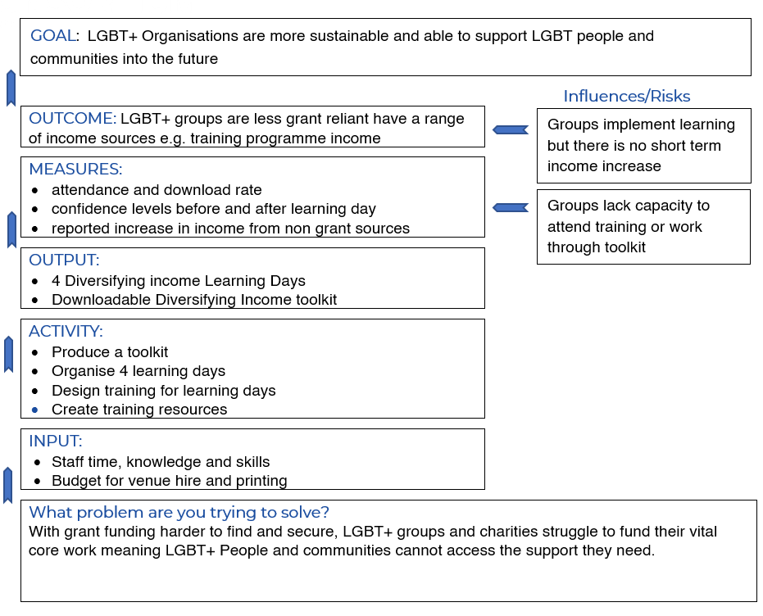
Consortiums LGBT+ Sector Outcomes Framework can be found here

Measure and Monitor
At certain points in the life of your strategic plan, you will need to check that your work is on track and is achieving objectives you set out in the plan. By setting performance indicators or milestones you can monitor progress, share news of achievements, and implement learning and make changes if needed.
Setting performance indicators or milestones means you are setting standards against which you will assess performance, so ask yourselves these questions:

- What will you provide? e.g. services, support, information, advice
- What do you want to achieve? e.g. increase in reach, serving a higher number of beneficiaries
- What do you expect to see at key points of the process? e.g. what will suggest that are achieving your objectives?
- What standards for performance might you already have in place? e.g. from funders or regulatory bodies?
The methods you use to measure work against your plan could be qualitative (based on figures such as averages) or quantitative (based on perception or experiences).

Just ask yourselves how you will know if you are on track and ultimately when you have achieved your outcomes and how you will demonstrate that to others.
For more information on setting outcomes and measuring your work watch this short video.

Writing The Plan

Know your audience
A strategic plan is created for multiple reasons, the most obvious being so that it can drive the organisation’s work but less obvious might be to communicate with service users, funders and public bodies. Consortium is led by its member's needs, so it must communicate that a. it understands those needs b. it has a plan to address those needs and c. it has a clear strategy with which to achieve that.

It can be nice to include quotes from volunteers and service users that you consulted or who fed into the plan.

Make your plan easy to follow for those who will use it, but also consider who else might want to read it:

☐ Staff
☐ Volunteers
☐ Trustees
☐ Beneficiaries or service users
☐ Funders
☐ Other LGBT+ Organisations
☐ Corporate funders (Potential)
☐ Public bodies, local authorities

Use this space to make a note of who would be interested in your plan.
Think about if the same version of the plan will be appropriate to all the audiences you chose, or might you want to create a full working version and a visual companion version?

Once you know who you are talking to you can pitch the level of information and the language you use to suit. If you want to create a summary document for the people who use your services or support, then don't expect them to be familiar with sector speak and an array of acronyms, be audience-appropriate.

Start
If you have worked through this toolkit you will now have a range of information to inform your plan. The planning process is essential but ultimately at some point, you will have to start writing it. We have supplied a list of what should be in a plan below, and a very simple template plan with guidance notes can be downloaded here.

Dedicate time to writing the plan, ensure you use all of the data and information you have collected to inform your work. The information from your theory of change can be a good place to start.

Appropriate format and key elements

Strategic Plans can take many forms but they should contain key elements:

Introduction
Introduction to the organisation, its key activities and beneficiaries
Background to the creation of the Strategic Plan and context of where organisation is
Optional: introduction from Chair of trustees
Context of your plan
Outline the planning process you undertook to add context and validity to your plan.
Summarise the environment you find your organisation in and include a brief analysis of what your PESTLE, and/or SWOT (or whatever tool you used) identified.

Vision, Mission and Values
Introduce revised vision and mission.
- Vision:
- Mission:
- Values:

Lay out the strategic vision:
Create a picture of what you want to achive, what will success look like?
Choose a practical way to layout your goals, outcomes and milstones

Measures of success; how you will know when you have achieved an objective including monitoring and evaluation of work

Financial planning and Implications; funding, contracts and how you are going to secure them

Resources; staffing, volunteers, skills, support needed

Risks; what might go wrong and how you will deal with it.

Implementing The Plan

Plot Key Milestones
Don’t just leave the details in the plan itself, plot milestones and key delivery dates in the relevant calendars. It is much easier to keep to your strategic direction if it is embedded in your everyday work tools. Do this across the team with relevant people and catch up regularly about progress.

Measure and Monitor
If you have planned how you are going to measure your work against the outcomes you set, then be sure to remember to use the methods and tools that you have chosen.
If you are setting Key Performance Indicators (KPIs) what are the measures e.g. volume of training, levels of satisfaction etc - make sure you have the right things in place to collect, record and monitor.
Plotting key dates into diaries is useful and ensuring that everyone involved knows how to monitor, record and review progress.

Use a phased budget approach
Breaking budgets into phases can be useful and make it easier to keep track of whats allocated, spend and planned. If you chose to develop a strategic plan for 3 years, then phasing into years might be enough, but phasing in quarters might provide a more detailed and easy to follow solution.

Use a phased outcomes approach
In the same way that a phased budget can help to track money, a phased approach to outcomes and help measure accumulative success. Breaking outcomes into short term, medium and long term outcomes prevents momentum and direction from being lost.

Regularly Review
This is important.
If you decide to use a phased approach you will probably naturally review your work and progress at the end of each phase but if you chose not to use that approach you will need to schedule review periods into your plan. The reason this is important is because you might be on the right track, you might have started drifting away from your mission or you might not be achieving what you wanted or planned.

Regular Horizon Scanning
Things change and of course, you cannot predict the future, but you can horizon scan to ensure you are up to date with changes that might affect your work or direction. Do not be afraid to alter your course if something happens, carrying on regardless without acknowledging the wider environment around you is not useful.

Continue to Develop the Plan
Things change, lessons are learnt and we should ignore these at our peril.
A strategic plan is a working document so don’t be afraid to review and revise at regular intervals. If your goals totally change, you might want to ask why and to ensure that they are still on mission but if the odd outcome changes to reflect a change in environment or funding – then so be it!

Get Support
Consortium exists to support its Members, so use it. Get in touch with your Engagement Officer or email the team here, they are on hand to read over any draft plans you might have to just offer any further support.

As you have worked through this Toolkit you will have gathered all the information you need to create your plan, policy or information pack. Most Toolkits have templates that you can download and transfer the relevant information from the Toolkit across to so that you have your bespoke piece of work for your group.

If your group needs any further support around the topic covered in this workbook please get in touch with our Engagement Team via email admin@lgbtconsortium.org.uk.

To find out more about Joining Consortium, visit our website for more information.

