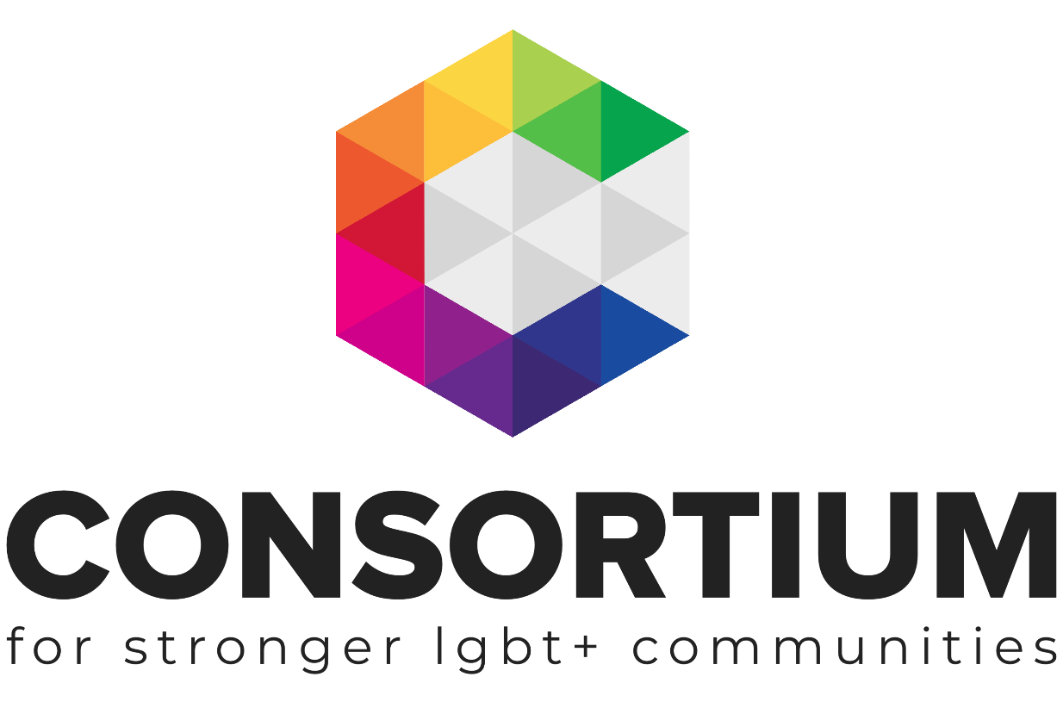
LGBT+ Futures Programme Workbook

Planning for Fundraising
Creating a Fundraising Plan and Building a Case for Funding

As part of the LGBT+ Futures Fund Programme Consortium and its partners are delivering a range of learning and skills development opportunities.
As part of the LGBT+ Futures Fund Programme, Consortium and its partners are delivering a range of learning and skills development opportunities.

These online toolkits are designed for LGBT+ Groups and organisations to work through with key volunteers, staff or Trustees to develop key policies, procedures, plans and management techniques.

As you work through the toolkit you will see a range of icons which are designed to alert you to additional information and support at the appropriate time.
Additional Support Available: Email us if you need more support or information whilst you are working through this toolkit.
Group Activity: Get your volunteers, colleagues or Trustees involved in this part of the toolkit
Additional Resources Available: This icon ndicates that there is more information on the topic

Webinar Available: Click on the icon or the link to find a webinar on the topic

Important Information: Don’t be tempted to skip a section with this icon next to it!

This Toolkit is not intended to be a definitive guide or template.
It is designed for LGBT+ groups to work through a series of activities and information in order to build a better understanding of the subject matter.
All the information provided was up to date at the time of creation.
This Toolkit was created by Consortium for the LGBT+ Futures Fund Skills Development and Training Programme 2019.
External Link or Resource: Indicates that there is a link to an external resource or webpage about the topic

Contents

Section 1: Planning for Fundraising
- What, Why and how.
Section 2: Building a Case
- Defining your ask
- Communicating your work
Section 3: Types of Fundraising
- Choosing the right fundraising methods for your group
Section 4: Fundraising Plan
- Looking ahead
- Planning
- Construct your own plan

Planning for Fundraising

Whatever type of fundraising your chose, its important to have a plan and to know what you’re asking for, who you’re asking for it from and how you’re going to ask for it.

Having a plan can reduce stress, ensure a steady flow of income and help groups plan their work over a period of time.

This Toolkit explores how you can build a case for support, chose which fundraising methods work for your group and then plan what your will do (including who will do it)

Building a Case for Support

A Case for Support is a document that tells potential supporters all about your group or organisation and inspires them to give to you. It’s written with your supporters in mind and answers the question: “Who are you and why should I give you my money?”.

When you have limited capacity for fundraising, your Case for Support becomes your best friend! You can adapt the information for funding bids, newsletters, reports, website copy, social media posts, leaflets, thank you letters etc. Some organisations put the entire document on their website or give it to donors.

Keep it simple – 2-6 pages is enough, you can also write a short version because if you are applying for funding through an application form, there will probably be a word count.

Write from the heart and with passion, but avoid sounding needy, begging or over-sentimental. Write as if you were talking directly to a supporter who is interested in your group. Keep the tone positive and upbeat.

What needs to go into a Case for Support?
Your Case for Support should include facts, figures, and logical reasons why supporters should give to your group. Don’t forget to inspire, stories and real-life examples of how your work or group has made a difference are interesting to those who read the bids!

Here’s a suggested structure:

Start with a story. Use a short case-study to show the difference your group makes. Supporters are influenced by stories.

Your vision. Explain what your group is trying to achieve. What difference are you making in people’s lives?

Your history. Give a brief account of your group’s origins: When it was established, why, and by whom? How has the group changed and expanded over the years? Why are you best placed to solve the problem?

The need. Provide evidence of need by including lots of data e.g. survey results, quotes from service users and experts who you work with, external reports. Make the need sound urgent, but solvable.

Your services and projects. Give a short explanation of what you offer, outlining the main features of every service or project. You can also mention external partnerships, where the funding comes from, and where the funding gaps are.

Your impact. How are you changing lives? How do you know this? Provide evidence of your impact by using facts and figures, quotes and case studies.

Your finances. How much does it cost to run your services each year? How do you raise the money? How much do you need this / next year? How much have you already raised? Present your budget clearly.

Your ambitions and plans. What else would you do if you had the money? What else are your service users asking you for? What are your priorities for the coming 1-3 years?

Your call to action. What exactly do you want supporters to do e.g. Give you a donation online or by cheque? Give a specific amount? Fundraise on your behalf? Give you a grant? Volunteer? Offer several ways to help.

Why your group deserves support. Reiterate the need and why you are the best group to deliver this work. Say thank you for their support!

What’s the process for producing our Case for Support?
You could task one person to produce it or do it collectively. Invite others in your group to read and comment before you finalise it. You could also ask your service users, existing supporters, a contact person from your local CVS infrastructure service… Find someone with design skills to make it look nice if you intend to publicise it.

What next?
Make sure everyone in your organisation has a copy – this is their guiding document when talking to supporters or anyone else about your group. Update it when needed, refer to it, use it. Adapt the information from your Case for Support whenever you are producing funding bids, newsletters or other materials Avoid just copying and pasting direct from it – best if your bids, communications etc are tailored to each kind of audience. You could also use your Case for Support to plan a public talk about your group e.g. a presentation to the local community, a company, charitable trust or other funder. You could create a slide show or video based on the information and upload this to YouTube and your website. You could find other creative ways to present the information.

Types of Fundraising

When starting to fundraise it can be tempting to try out lots of different types of fundraising techniques to see what works. However, this can be a waste of your time and resources. It’s better to select your fundraising methods strategically, based on your group’s aims, skills and capacity. The methods use choose will also ideally be sustainable – you’ll be able to ‘rinse and repeat’ and keep bringing income in for your group. Ideally, you should also choose a mix of methods, some that will bring money in quickly and others over the longer-term.
Each group’s circumstances are unique, so make some time to select the methods that are the best fit for you.

Resource: Types of Fundraising (ctrl & click)

Resource: Fast Fundraising Ideas (ctrl & click)

Resource: Membership Schemes (ctrl & click)

Resource: Generating Income through Trading (ctrl & click)

Resource: Regular Giving (ctrl & click)

Resource: Crowd Funding (ctrl & click)

Use the space below to note of which methods might be appropriate for your group.

Fundraising Plan

Your fundraising is likely to be more successful (and less stressful!) if you spend time creating a plan. A basic strategy contains a clear idea of:

What you need the money for
How much you need to raise
How you are going to raise it

A Fundraising Strategy will help your group to:
- be proactive with your fundraising, rather than just reacting when you’re running out of funds
- choose your fundraising methods carefully, to raise the chances of success
- use your fundraising time efficiently, so you don’t waste precious time and resources
- explain your fundraising approach to others within and outside of your organisation
- say no to ideas and opportunities that don’t fit within your strategy
- make a highly specific action plan that you can follow, instead of wondering what to do next
The process of producing your Strategy:
Decide who will write your Fundraising Strategy. One person or your whole team?

Decide on the number of years your Strategy will cover – 1, 2,3 or 5 years.

Define your aims. There should be a clear link between your group’s wider aims and the aims of your Fundraising Strategy.

Set your income target. Ask yourselves: How much will we need to raise to deliver our work over the next year (or 2, 3 or 5 years)?
Start with your existing services and list your predicted costs and expenses for the coming year. You may need to dig out old invoices and bills to more accurately estimate future costs. Ask yourselves if there are any additional costs you may incur in the coming year/s e.g. admin costs, legal or accountancy support, any new projects you’d like to offer?
Identify existing sources of income i.e. multi-year grants you’ve been given, regular donations from individuals, income from selling services, or other money you’ve already raised or are highly likely to raise for next year. Work out your income target by subtracting the amount you’ve also secured from the total amount you need to deliver your work.

Decide on your fundraising methods. There are numerous ways of generating income, but you need to select the techniques that best suit your group.
Questions to ask yourselves: Where did our money come from last year? Which methods did we use and what worked best?

What are our strengths, skills and assets? Do we have a list of current supporters? Do we have access to a space suitable for events?

What are our weaknesses e.g. limited time, lack of contacts and networks, lack of skill in certain areas, no evidence of need or impact, no case for support?

What are other groups that are of a similar size and type to us doing? Which fundraising methods seem to have worked for them?

Once you have the answers to those questions, you can decide on the fundraising methods you will use over the next year. It’s good to have a mix rather than rely on one method. But be realistic – if you’ve never tried a method before, you may need some training or support, and/or you may need to set a relatively low target amount. Be specific about each method you’ll use e.g. list the trusts you will apply to, the events you will run, how you will tackle individual giving… And how much you intend to raise via each method.

Put your Strategy together i.e. put your answers to the above questions into a structured document. Be specific about roles and responsibilities – who will do what?

Set out a timeline or calendar of your fundraising activities over the year e.g. if you are running an event in September, you will probably want to start planning at least 3 months beforehand; and if you need grant money, you’ll have to submit the bids 3-6 months in advance. Make sure your calendar fits with your group’s needs – do you need a regular amount coming in each month, or at a particular point in the year?

Set out the action steps you’ll need to take for each method, making them SMART (Specific, Measurable, Achievable, Realistic and Time-bound). It’s also a good idea to include any deadlines for grant applications and decision waiting times etc. that you know about.

Then you need to agree your Strategy. Ideally everyone in your group (volunteers, trustees, staff) will have an assigned role in the Strategy. Make sure you have their buy-in. You can also show the plan to some of your service users and supporters to ask for their views and get their feedback.

Monitor and review the plan regularly.
- Are you achieving the income you’d planned for?
- Are actions being completed?
- Is the money coming in?
Resource: Fundraising Plan Template. Once your group has worked through all of the above, download (ctrl & click) this simple template and copy the information across to have your groups Fundraising Plan.

Construct your own Plan

As you have worked through this Toolkit you will have gathered all the information you need to create your own plan and case.

Most Toolkits have templates which you can download and transfer the relevant information from the Toolkit across to, so that you have your own bespoke piece of work for your group.

If your group needs any further support around the topic covered in this workbook please get in touch with our Engagement Team via email admin@lgbtconsortium.org.uk.
To find out more about Joining Consortium, visit our website for more information.

