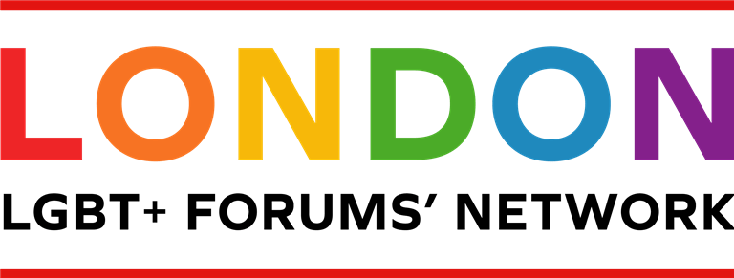
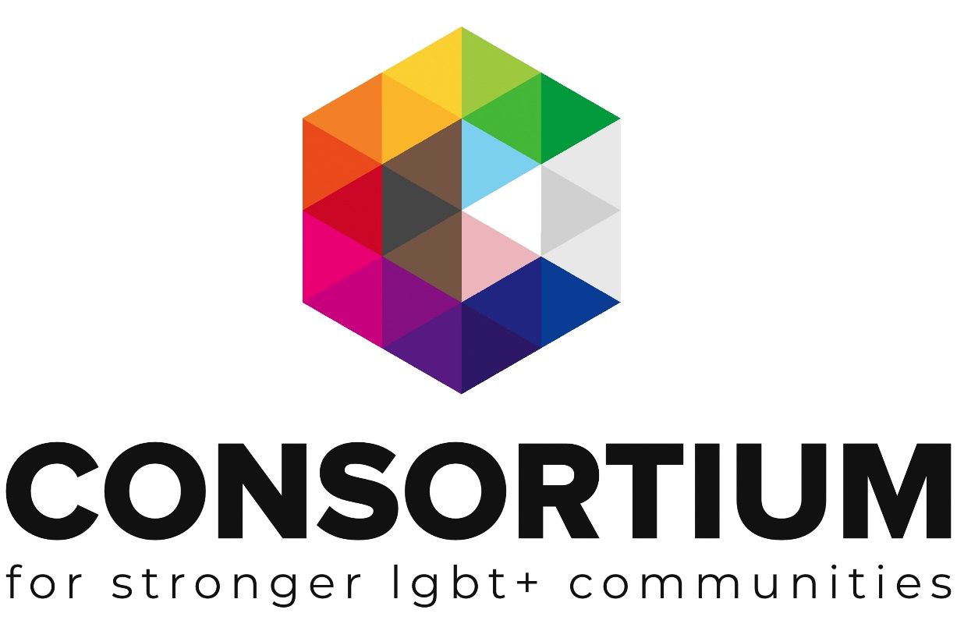
LGBT+ Forums Start Up

These online toolkits are designed for LGBT+ Groups and organisations to work through with key volunteers, staff or Trustees to develop key policies, procedures, plans and management techniques.

As you work through the toolkit you will see a range of icons which are designed to alert you to additional information and support at the appropriate time.
Group Activity: Get your volunteers, colleagues or Trustees involved in this part

Additional Resources Available: Click on the icon to find more information on the topic

External Link or Resource: clicking on this icon or a link by it will take you to an external resource or webpage
Important Information: don’t be tempted to skip a section with this icon next to it.
Webinar Available. Click on the icon to take you to a recorded webinar on the topic

Additional Support Available: Email us if you need more support or information

This Toolkit is not intended to be a definitive guide or template.
It is designed for LGBT+ groups to work through a series of activities and information in order to build a better understanding of the subject matter.
All the information provided was up to date at the time of creation.
This Toolkit was created with The London LGBT Forums’ Network working group 2020.

Contents

Launching a new forum
Support
Purpose
Structure
Finances
Funding
Promotions
Public meetings
Policies
Health & Safety
Insurance
Safeguarding

Launching a new forum?

Whether you are planning to launch a brand-new forum, or resurrect a forum that is no longer operating, there are a number of key factors to consider, to help things go smoothly.
Remember you are not alone!

There are many existing well-established forums as well as The London LGBT Forums’ Network. So, a good starting point is to view the London Forums map to get in touch with neighbouring borough forums or contact The London LGBT Forums’ Network: LondonLGBTForumsNetwork@outlook.com

To support you in these initial stages why not become a Consortium Member. Its free to join for low/no income groups and you will gain access to an extensive range of resources, training, access to our Funder database, discounted insurance and 1:1 support. Please do get in touch to find out about joining

Below are some key start up questions to consider and links to relevant support documents. There is no ‘fixed way’ to go about setting up a forum and the information below is based on input from The London LGBT Forums Network working group based on their experiences.

If a section does not feel relevant to your situation, just move on to the next topic.
Though do keep in mind, any sections marked with the ‘important icon’
should be considered by all.

Support

Is there a group of individuals interested in setting up the forum with you or are you currently looking at this on your own?

Don’t worry if you are exploring this on your own – there is lots of help out there. As outlined above, why not view the London Forums map to see who is running a group near you and / or get in touch with the The London LGBT Forums Network for support: LondonLGBTForumsNetwork@outlook.com

Think about any network contacts you have of people you could invite to explore it with you?

Consider possible community partners and allies who may be able to support you and if relevant and get in touch with local:
- Statutory bodies (such as the NHS, Police and Local Authority).

- Volunteer community sector.

- Business and corporates.
And if you are not sure where to turn, do get in touch with Consortium and established forums for support.
Return to Index

Note down your potential forum colleagues / support network contacts and it can also be useful to include their relevant key skills and areas of specialism.

Purpose

What is the key purpose of your forum?
These are some of the key areas identified by existing groups within the main themes of: Health, Safety and Culture

Tick all those that you feel may be relevant to your proposed forum and add any others that are not listed:
To liaise with your local authority on LGBT+ equality matters. *
A link between LGBT+ community members and partners.
A link with the local police / hate crime coordinator.
Providing social opportunities for the local LGBT+ community.
Hosting events / Prides to raise the profile of the LGBT+ community in your area
Organising and running support service groups (often more relevant to well-established forums.)

An information ‘hub’ signposting to opportunities, services, and provisions.
Other areas of focus:

*Remember it is important to remain party-political neutral regardless of personal / individual views in to order to best represent local borough communities and build effective working relationships with your local councillors, London Assembly Members and MPs.

When considering the purpose of your forum and areas you may like to develop, it can be helpful to also think about who may be able to support you locally or provide helpful guidance. For example: local MPs, local councillors, Local Authority key staff, NHS and health staff, Voluntary sector organisations.

Note down any existing contacts you have and / or search online for local contact information:

Structure

To help your forum take shape it is useful at this stage to explore which organisation structure you think will suit your forum best. Most small groups start out as unincorporated groups and then as they expand become more formalised to keep in line with current regulations on income and so on.

Return to Index
The structure you choose will enable you to define how decisions are made and who is part of that process. There are a number of options that best match different needs from informal unincorporated groups through to registered companies.

Unincorporated Groups are the simplest type of organisation. They are cheap and simple to set up, but please note, Trustees take on personal liability and shared responsibility for the group’s actions.

For more information to help you decide, take a look at this resource:
Guidance Tool Legal Structures

Discuss with your forum colleagues and note down your thoughts with regards to the most appropriate structure for your needs and any actions you need to take to put the structure in place, such as developing a constitution.

If you are unsure on which structure to opt for or would like help developing your constitution / incorporating your group etc, please contact Consortium’s engagement team for support.

As part of this process you will also need to consider what your forum will be called. If you are resurrecting an existing group, you may decide it’s a good time to change the name.

Keep in mind if an existing forum is incorporated and you choose to change the company name this will require a legal change and impacts on the constitution, bank accounts, Companies House, and so on... It may therefore be preferable to maintain the ‘legal name’ but focus your logo and brand with the new wording.

For example: legal name LGBT Worcester Community Forum

Logo and brand ‘working name’: Worcester Rainbow

If the group has charity status you will need to inform the Charities Commission of your working name (even if there is no change to your legal name).

Discuss with your forum colleagues and jot down ideas for the forum name. Take a look at existing LGBT+ forums to get ideas – many opt to include the borough in the group name for clarity. You may decide to take a vote to choose a winner!
For further information around branding, please request our factsheet.

Basic Finances

This may not be a concern in your early stages, but it can be useful to think about setting up a bank account or partnering with a larger organisation and utilising their facilities.
Return to Index
Take a look at our factsheet on holding money and bank accounts.

If you are planning to open an account, note down who will be your signatories (best practice advises 3 signatories registered to the account).

If you are seeking to hold funds with a partnership organisation – make a note of those that you may be able to approach (for example an established local LGBT+ support group).

In line with the factsheet do NOT hold money in your own a/c for your group

Funding

In the early stages you may not require significant funding. Ideally you will be able to secure a venue at no cost and online promotions (see below) are free, so it may simply be a matter of providing basic refreshments (teas / coffees / biscuits) for initial meetings. Consider approaching local supermarkets as they may be willing to donate products or provide a gift voucher.

You can also explore fundraising options to generate a small float. Take a look at our ‘Fast Fundraising Ideas’ factsheet for inspiration.

Consortium members can access our Funder Finder: a directory of funders that we know are supportive of LGBT+ groups and organisations.
Please do get in touch to find out about joining.

Note down any initial fundraising ideas

Promotions

In order to reach the local LGBT+ community in your borough it is important to think about the different ways you can get information out about your new forum. Liaise with your forum colleagues / support network that you identified in the activity above, especially if individuals have any promotional experience.
It is best practice to avoid using your own personal phone number and social media accounts when reaching out to community members. If it is not viable to fund a separate phone, consider email as the main means of contact on your promotional materials.

Have a look at the list below and tick all of the promotional options that you feel are accessible to you / options that you’d like to pursue. Keep in mind some of the options may require a small amount of funding, for example to print flyers:
Return to Index

Promotional options
Facebook page
Twitter
Instagram
Website
Leaflets (e.g. to display in your local library / supermarket notice boards etc.)
Local newspaper advert
Mailing list (if resurrecting an existing group.)
Via relevant organisations (e.g. a blog / post on another organisation’s website, social media etc.)
Other promotional ideas:

Public meetings

When arranging forum meetings to connect with your local LGBT+ community there are a number of factors to consider:

- Consider whether your meetings will be online or in person (or both).

- Ensure the venue you choose is LGBT+ inclusive.

- Consider accessibility needs.

- Avoid venues serving alcohol.

- Ensure the venue you choose is well connected by public transport.

- Ideally select a venue that will be staffed during your meeting (this helps minimise health & safety risks and avoids issues such as needing keys to access/lock up).

- Consider the timing of your meetings for maximum reach: early evenings can be effective or weekend day times.

- Consider ways to ensure your meeting is welcoming to a diverse membership: for example, late evening meetings may put off older people, does the venue have gender neutral toilets etc and as mentioned above avoid venues with alcohol to include different faith groups.

- Consider available funds and ideally seek venues offered at no cost.
Public libraries are often a very good starting point for initial meetings to address many of the above criteria.

You may also consider getting in touch with your Local Authority and / or CCG for potential venues.

Note down any suitable venues you wish to approach and contact info if known

Return to Index

Basic policies

There are some key policies that you really should have for your LGBT+ Group covering topics such as safeguarding, equality and diversity and data protection.
These policies should be in place to protect both those running the group, and those using the support, services or events offered by the events.

Below is a list of some of the essential policies all groups should have, and then a list of policies that it would be good practice to have (if relevant).

Have a look at the list below and tick all of the policies relevant to your group that you need to put in place:

Essentials
Health and Safety
Equality and Diversity
Data protection and confidentiality
Complaints
Volunteer policy
Safeguarding policy

Others
Financial management
Bullying and Harassment
Conflicts of Interest
Reimbursing Expenses and Purchases
Whistle Blowing
HR policies relating to paid staff

Please contact Consortium if you would like 1:1 support to develop your initial policy documents and don’t forget that members can access our resource library which includes a number of useful templates.

Health & Safety

With any public meeting and particularly voluntary sector groups, vulnerable individuals may attend including those with mental health issues, so it is helpful to think through some basic health & safety factors to ensure the wellbeing of individuals, your team and other group attendees.

There is also the risk that hate groups or HBT-phobic individuals may attempt to gain access to meetings in order to cause disruption and distress.
Remember you are not alone – please do contact Consortium and established forums for support. You may be able to invite along colleagues from a neighbouring forum to your initial meetings for support. If you are able to secure a venue that is staffed during your meeting, as outlined above this will help minimise health and safety risk factors.
Other ways to reduce potential risk include:

- Ensure you have been given relevant fire procedure information from the venue you are using.
Return to Index

- Ensure you have a least two forum team members present before you welcome in guests.
- Have a sign-in sheet to record who is attending.

- You may wish to withhold the venue address from public promotions and request people get in contact for the information – however this may act as a barrier to attendance.

- Consider your forum colleagues – and if possible, ensure at least one person is present who has experience in managing difficult situations (such as those in frontline public sector roles).

- If you are providing any refreshments, ensure items are labelled / or original packing is available for those with allergies.

- Ensure you have access to a phone in case you need to make an emergency call.

Insurance

Government guidelines state: There is no law that states you must buy insurance for a voluntary or community event – but you might want to make sure you are covered in case something goes wrong and someone makes a claim against you. If you are renting or using someone else’s building, you may be covered by their insurance, do check to see if this is the case.

Consortium members can access discounted insurance, so do visit our website to find out about joining.

Safeguarding

For any group connecting with members of the public, it is important to have a basic understanding of safeguarding. Safeguarding is protecting vulnerable adults or children from abuse or neglect. As outlined in the Health & Safety section above you may encounter vulnerable individuals including those with mental health issues, drug and alcohol issues and so on. An important first step for any group working in the community is to contact your local safeguarding board for support:

Your local Safeguarding Board coordinates all local work to safeguard and promote the welfare of children and vulnerable adults and also provides training (usually free) to any individuals who work with children/vulnerable adults. The Board are also there to advise and do keep in mind that at any point if your forum has a safeguarding concern, a query or even if you are clear on what to do but you just want reassurance – you can contact them!

A simple internet search of ‘safeguarding board (your borough)' will take you to the relevant website.

Note down the web address and any key contact phone numbers listed so you have these recorded if ever required.
Return to Index
Also liaise with your forum colleagues / support network and note down if you have any colleagues with safeguarding training such as those in frontline public sector roles who may be willing to act as a ‘Safeguarding Lead’.

Consortium has produced a comprehensive toolkit to support groups to develop a safeguarding policy and those wishing to review/audit their existing policy. Click here to request the toolkit.

For further information about running community events please access this comprehensive government guide

Now that you have worked through this introductory workbook you may wish to transfer your activity responses onto a forum start up template so that you have all the relevant information in one simple reference document.
Access the template here.

This Toolkit was created with The London LGBT Forums’ Network working group, with huge thanks to:
Return to Index
Forum + (Camden & Islington)
Lambeth Links
Lewisham LGBT Forum
Merton LGBT+ Forum
Southwark LGBT Network
Sutton LGBTQ+ Forum
Wandsworth LGBTQ+ Forum

